**PROJECT 1**

**CINEMATIC TRENDS: EXPLORING MOVIE METADATA AND VIEWER PREFERENCES**

**Team Members:**

**Sashidhar Chary Viswanathula (11714360)**

**Dimpu Nithish Karanam (11823599)**

**Vidya Gangasani (11702121)**

**Problem Statement:**

The movie industry produces a huge amount of data, from movie genres and release dates, ratings and popularity metrics. But it can be challenging to understand what truly drives a movie’s success or failure. This project focuses on uncovering insights into viewer preferences, genre popularity, trends in movie ratings over time, and Profits earned by a movie.

By analyzing the two datasets of movie metadata and ratings, we plan to answer questions like:

* Do certain genres consistently receive higher ratings?
* How does a movie's release year or runtime influence audience perception?
* Are there patterns in viewer behavior that correlate with popularity or average rating?
* What is the average budget of a genre, and average profits earned?

We are focusing on communicating these insights through interactive and engaging dashboards that reveal how people engage with films.

**Workflow Diagram:**

This is the Workflow diagram for the project 1, We started off by collecting the dataset from Kaggle and loading it to the Google collab, after that preprocessed the dataset using Python and loaded the preprocessed dataset into power BI to generate meaningful insights and visualizations.

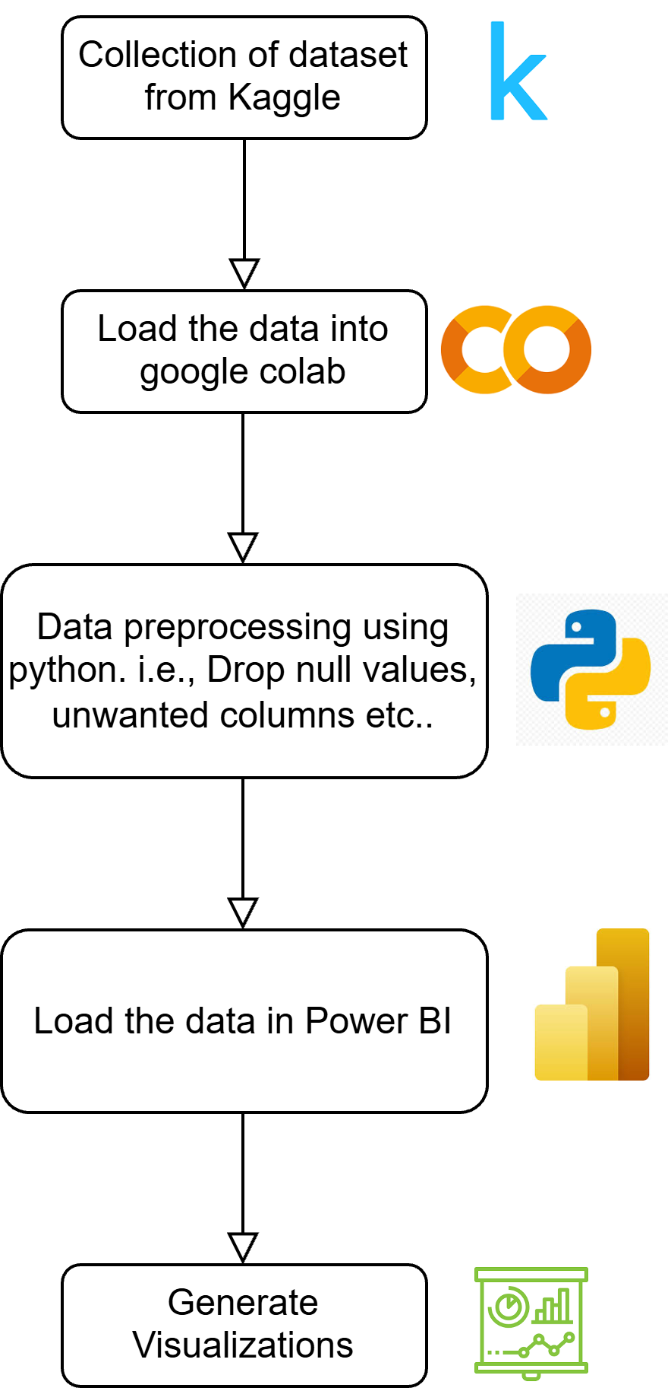

**Data Abstraction:**

For this project, we are using datasets from Kaggle, which are publicly available and have rich information about the movies and their ratings. We’ve used a structured dataset, but it has complex columns which have a JSON type in it. We processed the JSON type columns to get the data we needed from those columns.

**movies_metadata.csv (From Kaggle – TMDB dataset):**

Contains information about movies like titles, genres, budget, revenue, runtime, popularity, release dates, production companies, and more. This will help us analyze movie characteristics and metadata.

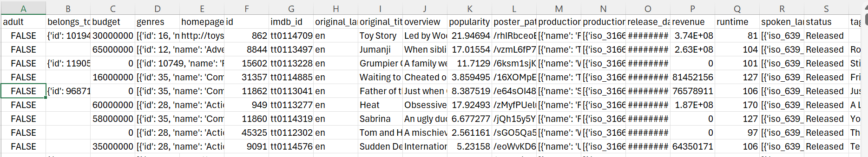

**ratings.csv** (**From Kaggle – TMDB dataset**):

This dataset includes over 100,000 user ratings for movies. Each rating includes a user ID, movie ID, rating score, and timestamp which allows us to evaluate user behavior, preferences, and seasonal trends based on the ratings.

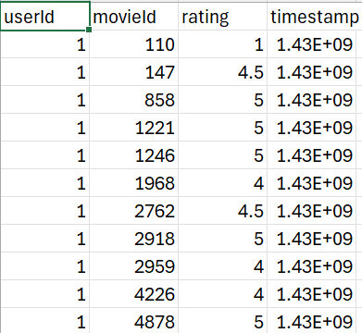

**Dataset Merging and Final Data Preparation :**

To enhance the depth of our analysis, we merged two datasets:

* movies_metadata.csv: Contains detailed movie information such as genre, budget, revenue, popularity, runtime, and release date.
* ratings.csv: Contains over 100,000 user ratings, including user IDs, movie IDs, rating scores, and timestamps.
* The merged dataset, named movies_data.csv, combines both movie characteristics and viewer behavior insights.  
  This enriched dataset enables a more comprehensive exploration of the relationships between movie attributes and audience preferences

Key Highlights:

* Integration of movie metadata with user rating patterns.
* Ability to analyze correlations between production features (e.g., genre, budget) and user engagement (e.g., ratings, vote counts).
* Foundation for creating deeper, more meaningful visualizations and insights.

*Below is a sample view of the final merged dataset:*

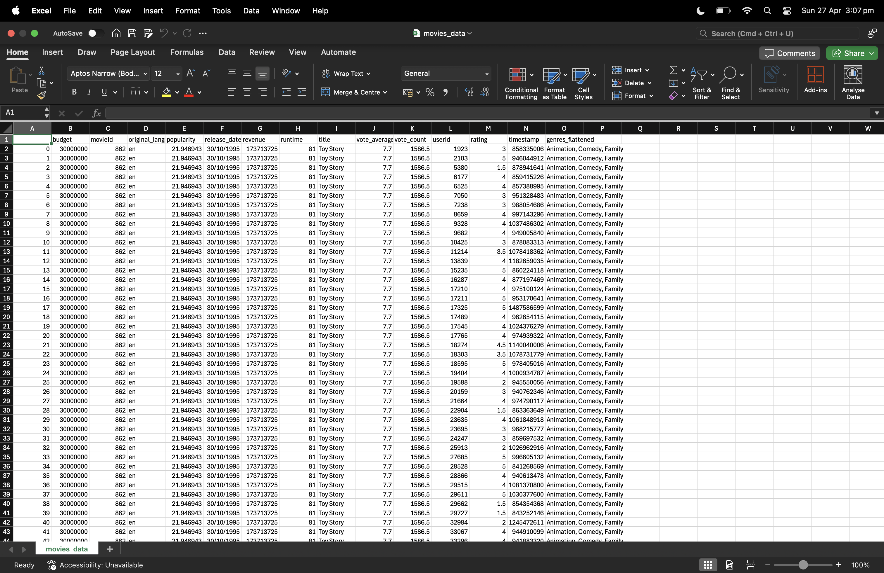

**Data Transformation:**

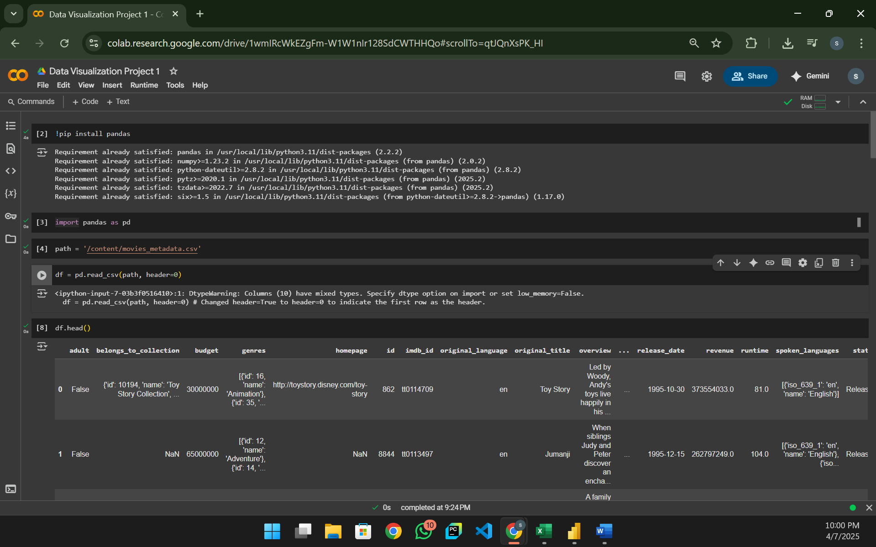

Here we can see that the dataset is loaded using pandas framework and df.head() is called to expose the first five rows. The dataset is not clean and transformed. There are many unwanted columns, null values and nested data.

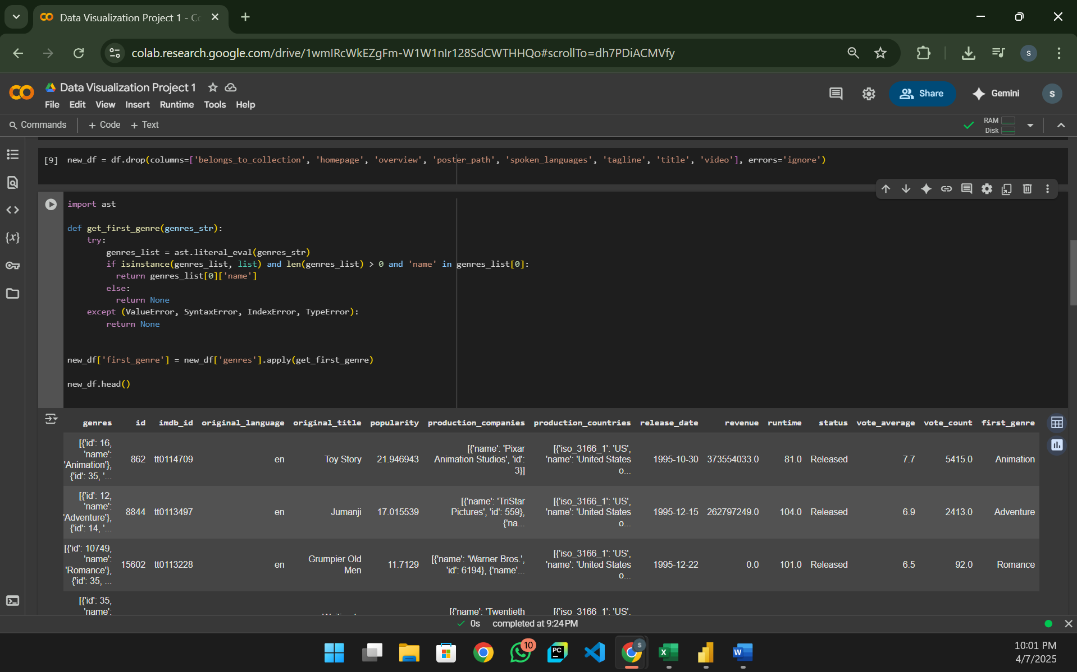

Dropped unnecessary columns and retrieved the genre form the nested list.

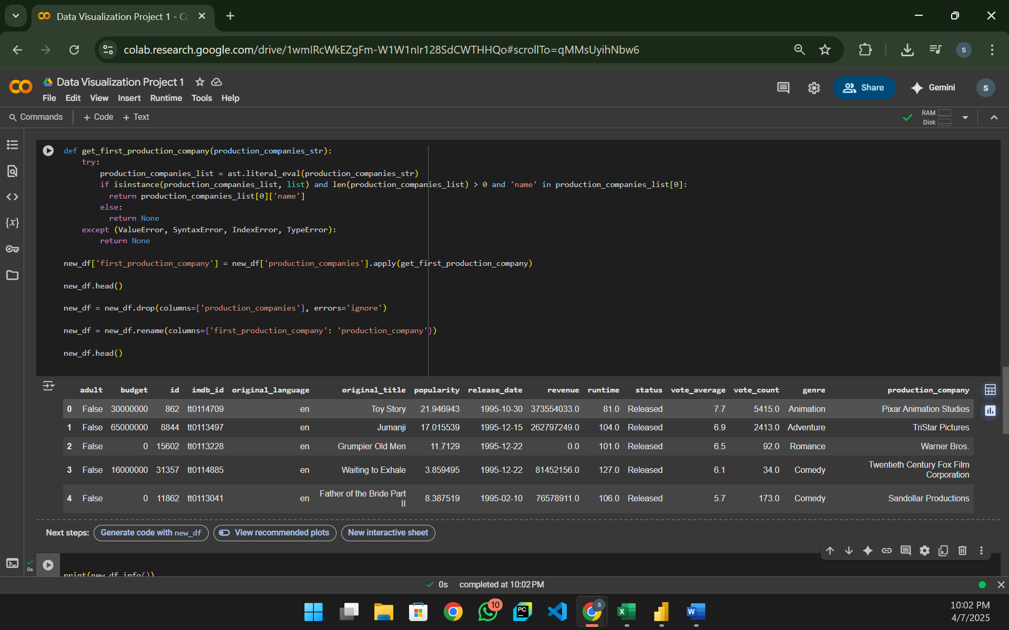

Now we can see that the dataset is cleaned and transformed.

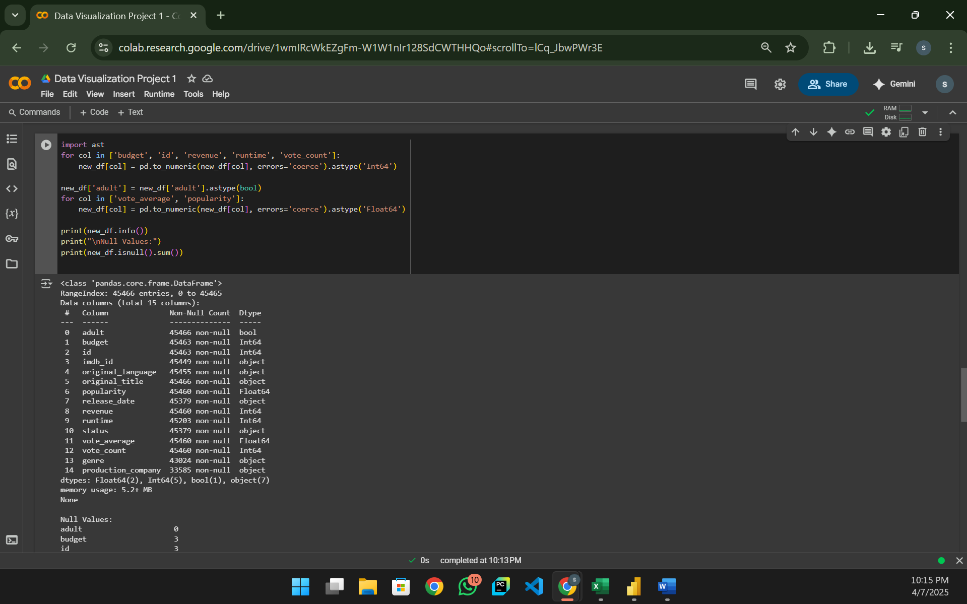

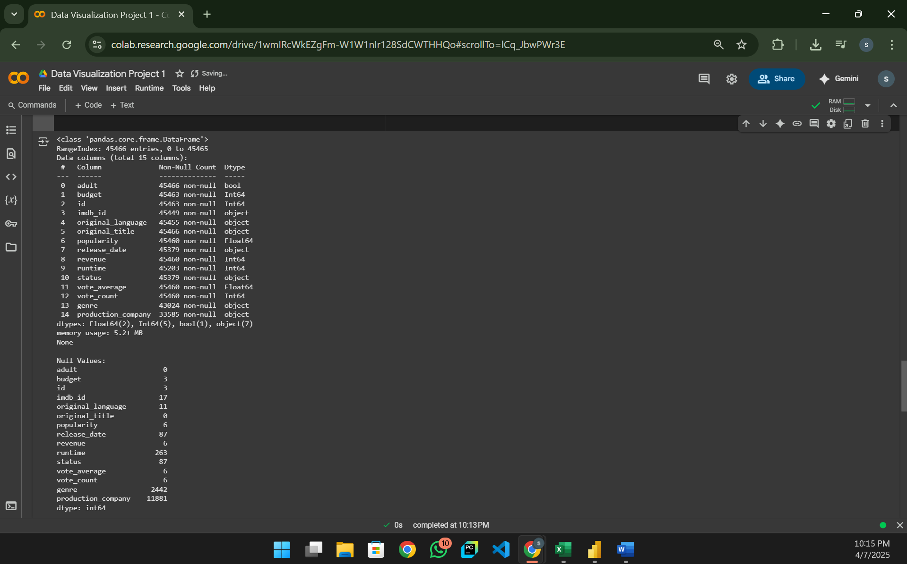

Here we have changed the datatypes of the columns to their appropriate datatypes like int and float. The dataset also have lots of null values, which are handled in the next step.

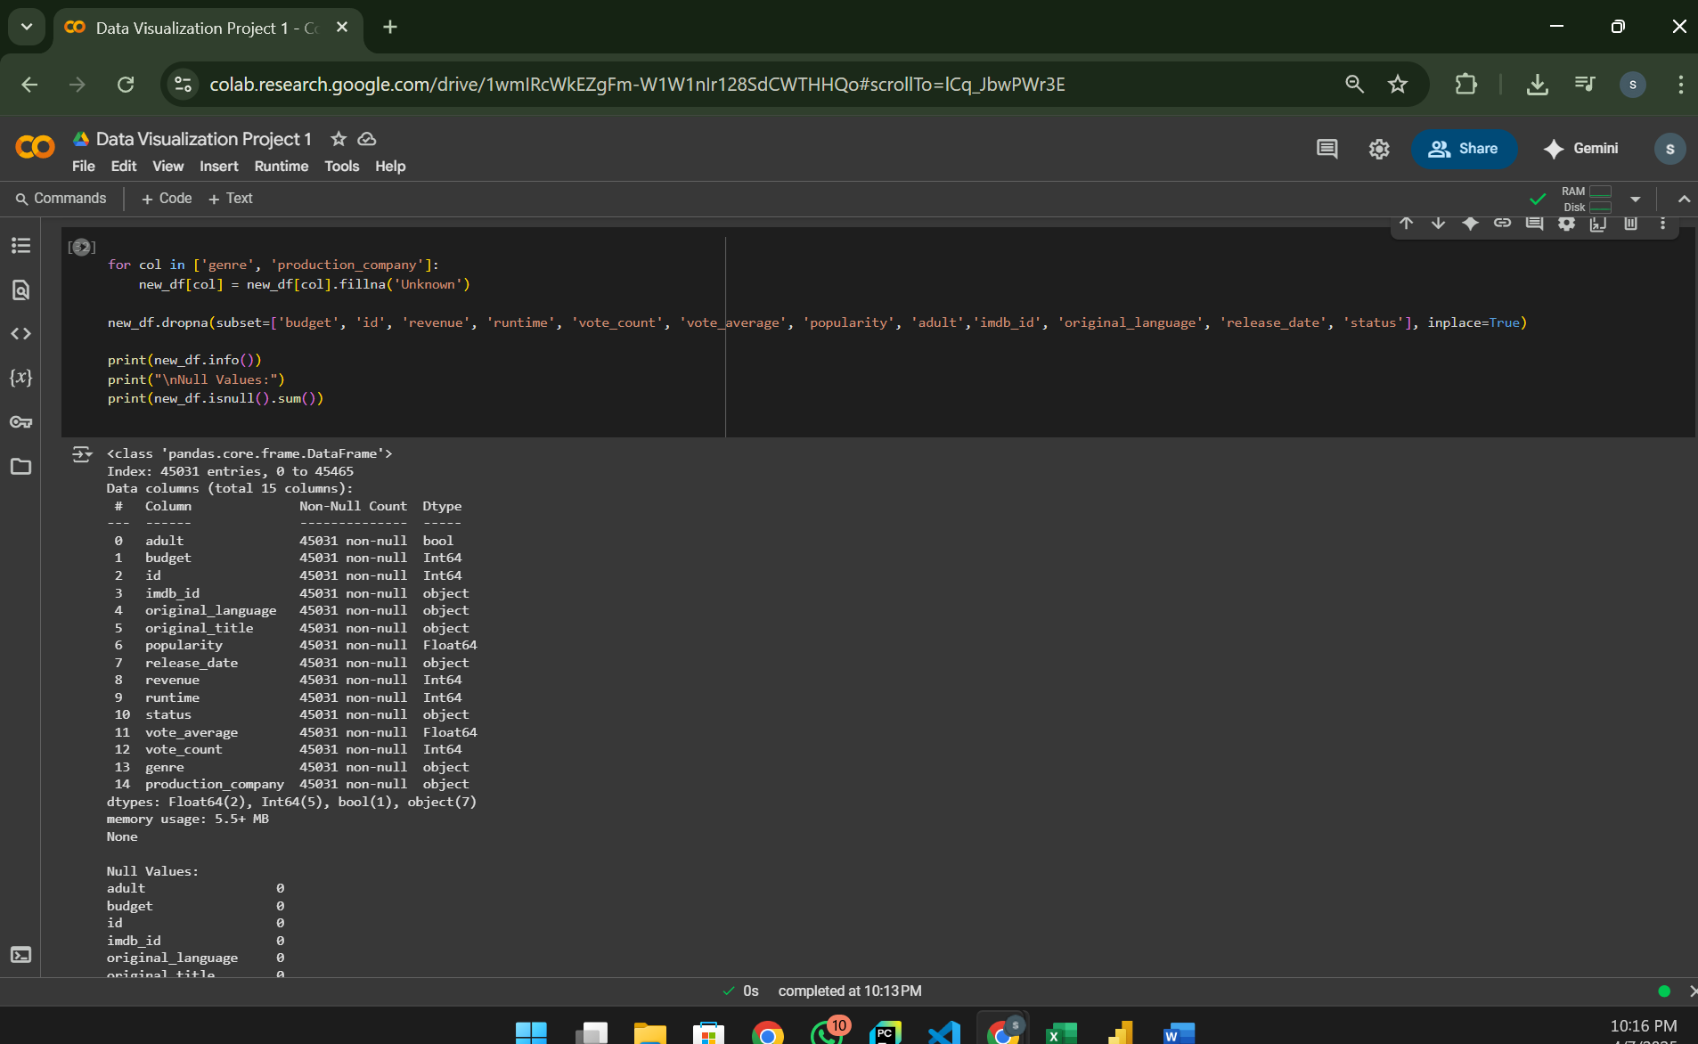

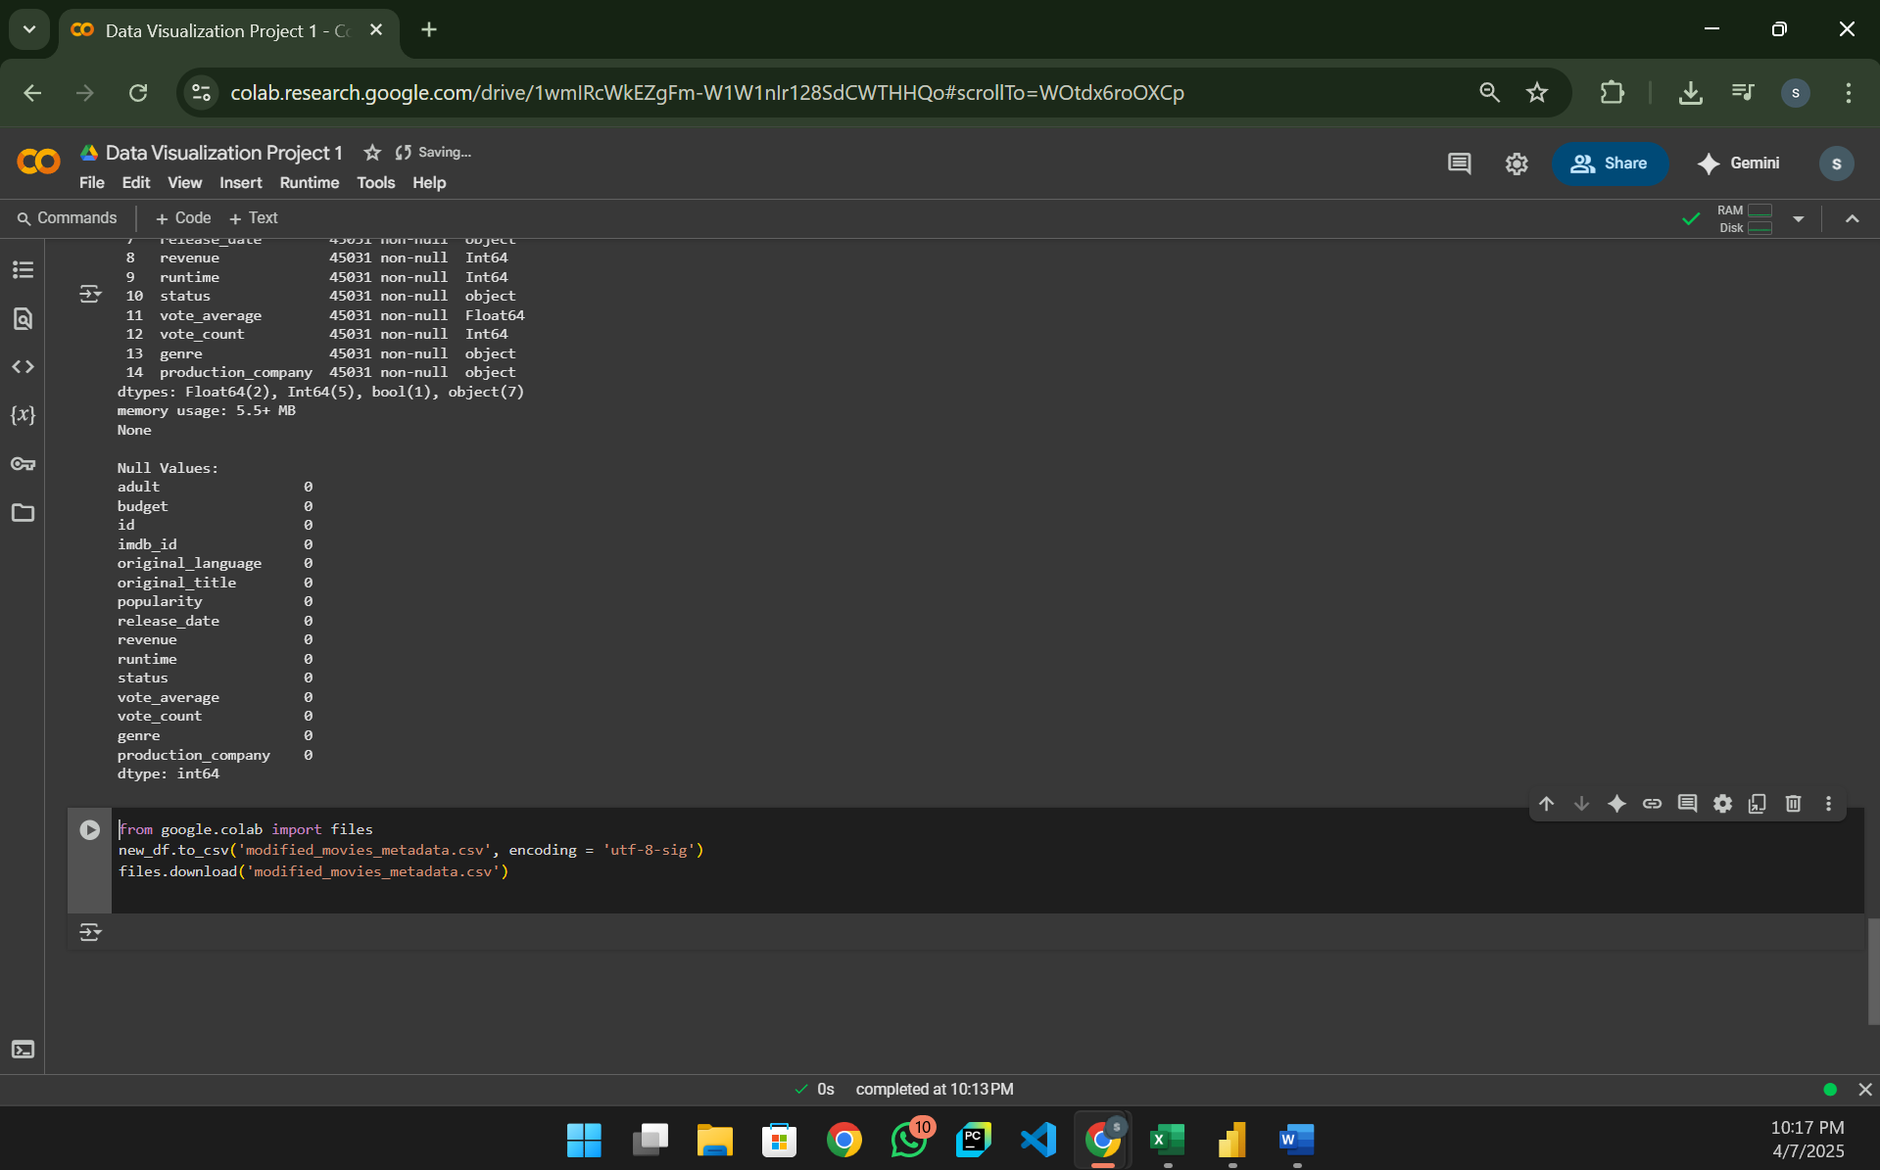

Here the dataset has no null values because they are dropped. Therefore, our dataset is clean and transformed ready for visualizations.

**Target:**

We are planning on analyzing:

1. Revenue VS Budget Analysis
2. Top genres by average rating
3. Trending popularity over years
4. Runtime distribution
5. Movies by language
6. Top production companies by revenue
7. Vote count vs vote average

**Actions:**

1. Filtered the data that doesn’t make sense or bring any value to the project. Like null values, unwanted columns etc...
2. Aggregated the columns to get more granularity on the project and much more summarized analysis.
3. Found relation between budget, revenue, release date, popularity.
4. Utilized suitable visualizations to better understand the data. (E.g.: bar chart, scatterplot etc...)

**Tool used for visualization:**

For this project, we have utilized Power BI to generate visualizations because it is easy to use interface and data loading is easier and flexible in this platform.

**Data Loading:**

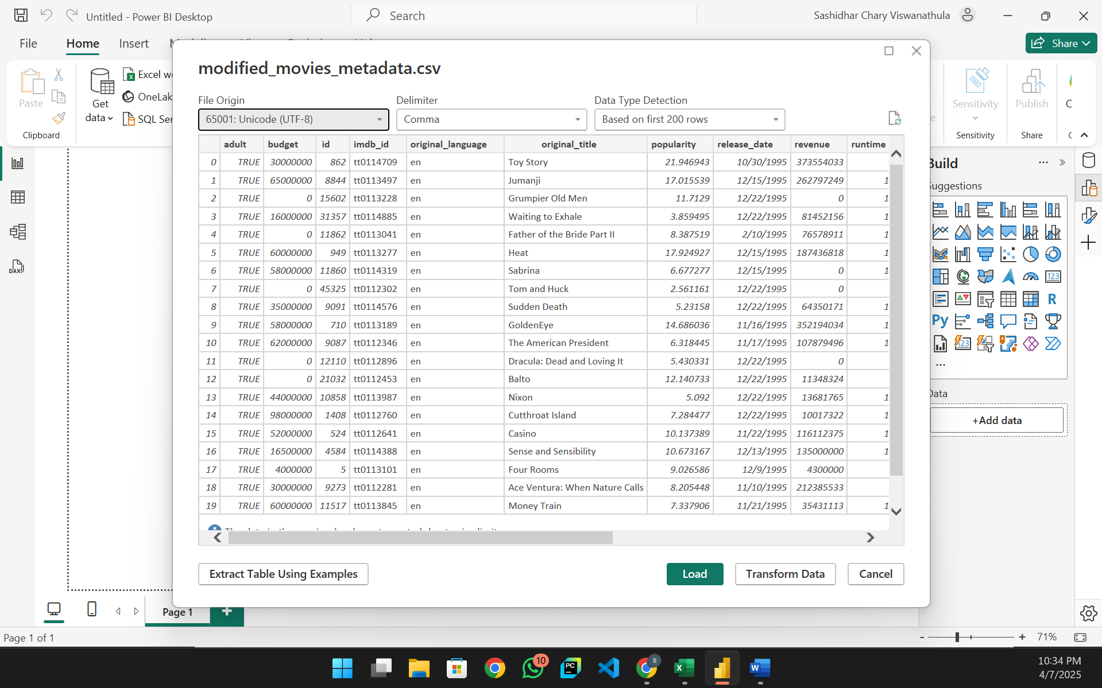

**Visualization 1:** **REVENUE VS BUDGET OVER TIME**

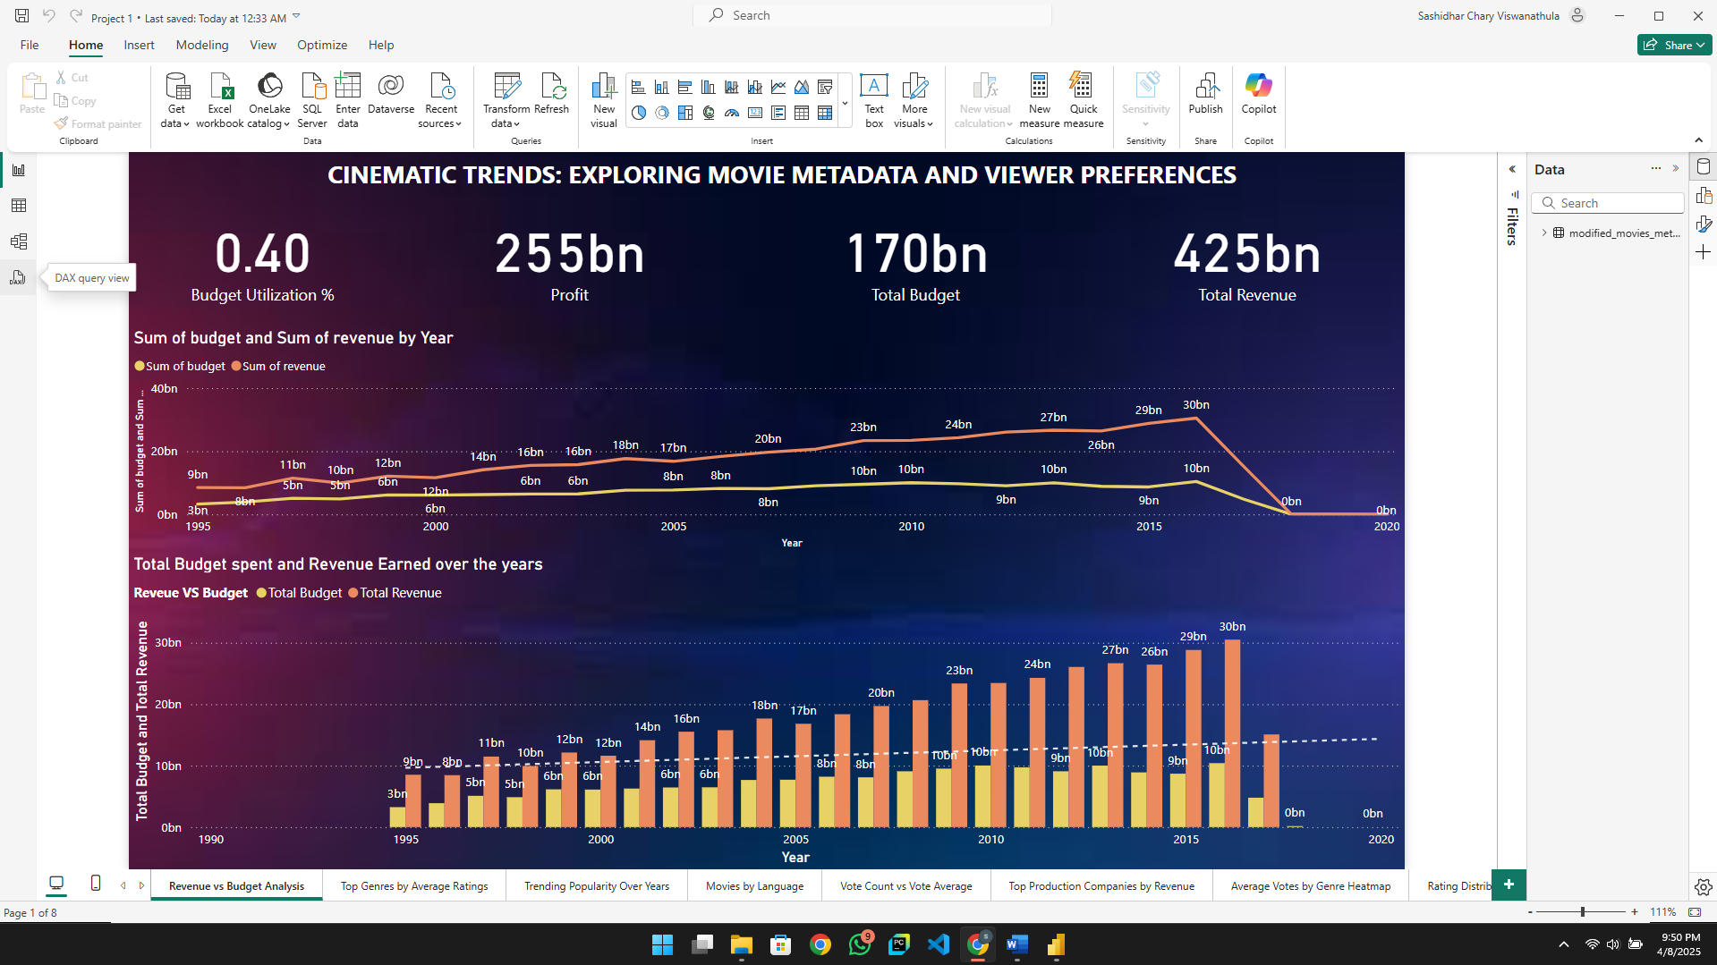

This visualization compares total revenue vs total budget per year which is in the bar chart and trends of both overtime in the line chart. This page also has highlights summary KPIs for budget utilization percentage, total revenue, total budget, profit.

**KPI’s:** By seeing the KPIs, we can say that the budget utilization is at 0.4%, which is extremely low, indicating very low budget utilization. The Profit is 255 billion, total budget is 170 billion, total revenue is 425 billion. Despite a low budget utilization percentage, the industry has generated a substantial profit of 255 billion, showing a strong return on investment over the observed period.

**Line Chart:**

The above chart shows the sum of budget and revenue by year from 1995 to 2020. As we can see, budget (Orange line) remains relatively studied between six billion and 10 billion from 2000 onward and revenue (Pink line) shows an upward trend, peaking sharply at 30 billion in 2018 then dropping to zero in 2020 (Possibly due to Covid 19 shutdowns).

**Stacked Column Chart:**

The above stacked column chart shows revenue vs budget over the years yellow bars represent budget orange bars represent revenue. There is a visible gap between the two which is the two bars. Revenue bars Are always higher, signaling profit every year. The trend becomes more significant post 2005, showing increased revenue even though budgets grow only slightly.

**Insights:**

By observing this PBI report we can say that the movie industry has maintained a healthy financial trend over the years, with profits increasing significantly relative to budget. The 30 billion revenues in 2018 was the highest performing year the impact in 2020 is worth highlighting.

**Visualization 2: VOTE AVERAGE OF GENRES**

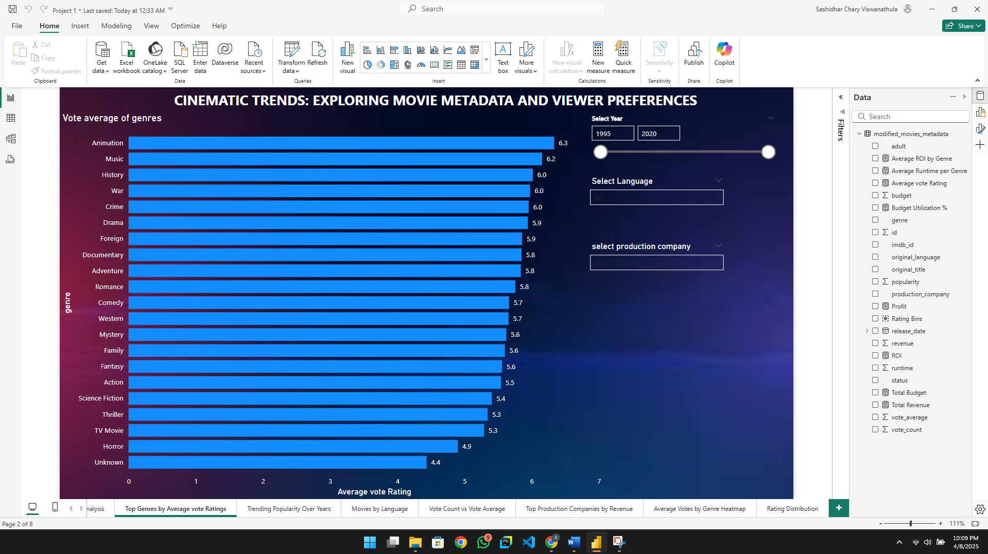

This visualization represents average voting votes of genres. This is a horizontal bar chart displaying the average vote rating for each movie genre we have used a dax measure called **average vote rating = AVERAGE (modified_movies_metadata[vote_average])**. The slicers (Year, language, production company) Remind the same, enabling interactive filtering for deep exploration.

**Insights:**

On the X axis we have average vote rating and on the Y axis we have genre. This chart displays the average audience rating for each movie genre based on voting data from the data set it allows us to compare how positively or natively weas have rated different genres on average.

By seeing the visualization, we can say that animation has a rating of 6.3, music 6.2, history or war or crime 6.0 are the highest rated genres. TV movie is 5.3 and thriller 5.3 are underperforming, possibly due to lower budgets, production quality or niche appeal.

**Visualization 3:** **TRENDING POPULARITY OVER YEARS**

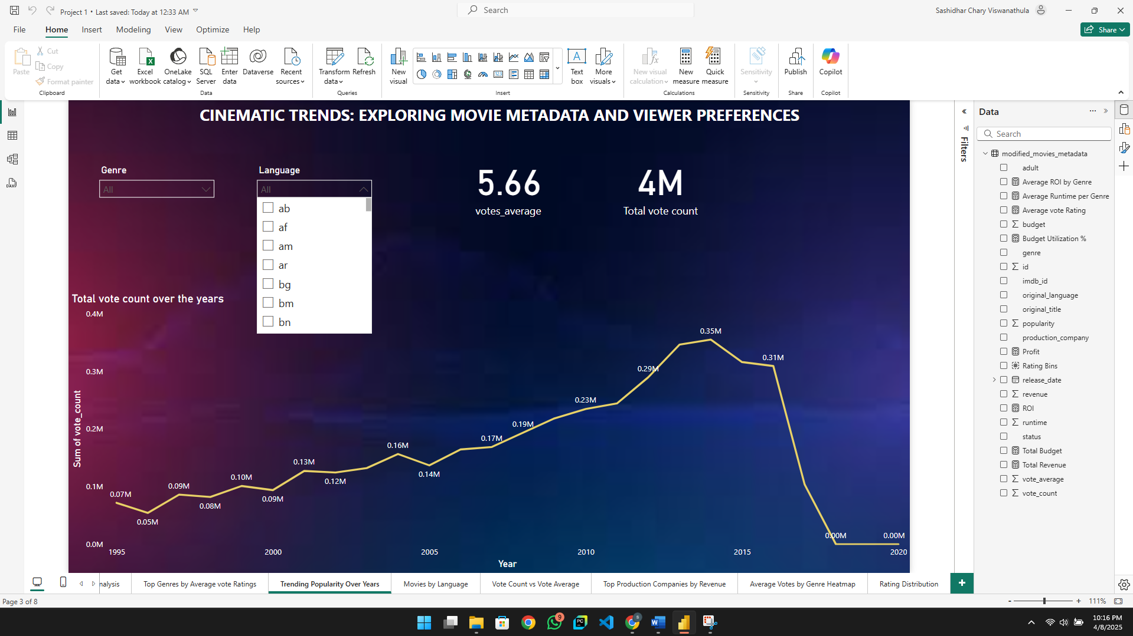

The above line chart shows the sum of vote count by year from 1995 – 2020. Here I’ve utilized two KPIs which are average board rating and total vote count and two filters which are genre and language.

By observing the chart, from 1995 to 2005 a steady slow growth in both counts from 0.04M to 0 .12M which tells us that the digital movie platforms or metadata sources were limited in audience interaction. From 2006 to 2014 a significant spike from 0.16M to a peak of 0.35M votes in 2014 says that there is a sharp price in increased digital engagement, due to the rise of online movie databases, streaming platforms or mobile access to content from 2015 to 2018 vote counts remain relatively high indicating sustained viewer activity from 2019 to 2020 a dynamic drop to zero votes this is most likely due to disruptions like the COVID 19 pandemic which stalled movie releases and audience interaction.

**Insights:**

We can say that there is a clear correlation between year and digital audience engagement watch rise steadily with Internet and streaming growth. The sudden drop in 2019 to 2020 is because of the global impact of COVID 19 the inclusion of genre and language filters alert us for detailed investigation into how specific categories or language based films trended in popularity overtime.

**Visualization 4: MOVIES BY LANGUAGE**

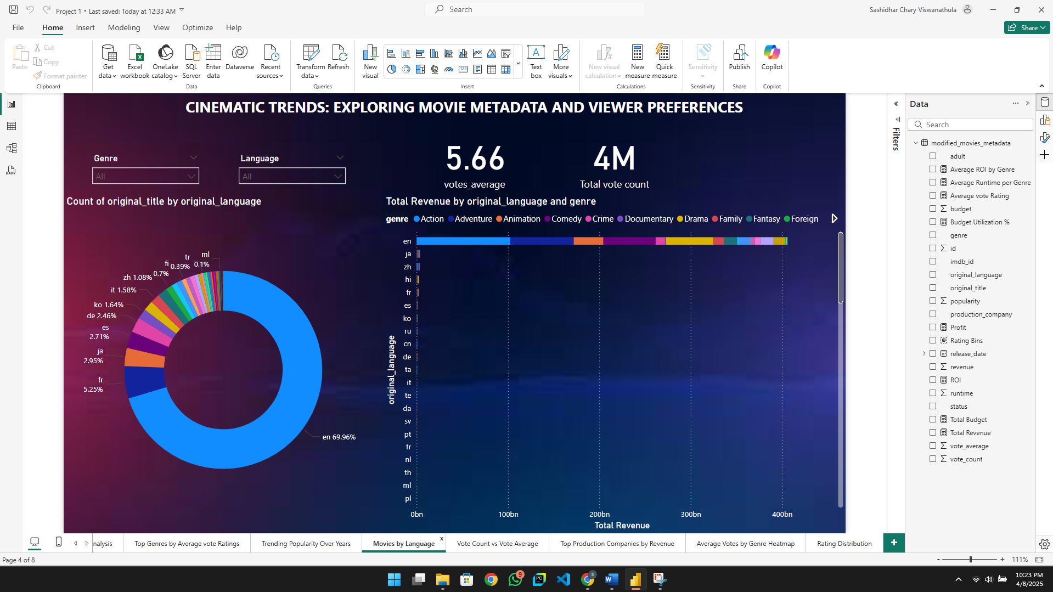

In this Visualization we have used two charts, one is doughnut chart, and one is bar chart. Represents a distribution of movie count by the original language in which they were produced. There are also two KPIs here, one is average vote rating, other is total vote count.

**Donut Chart: Percentage of language:**

By observing the donor chart, we can say that English is the dominant language accounting for 69 .96% of all movies. Other languages like Hindi are 5.2%, French 2.9%, Japanese 2.7%, Spanish 2.4%, Korean 1.6% and rest other languages are less than 1%.

This shows a heavy lean towards English language films, which is common in global movie datasets however non-English films do show up in notable volumes, especially from Bollywood.

**Bar Chart: Revenue by language:**

English not only dominates in volume but also in total revenue reaching over 400 billion non-English languages such as Hindi Japanese Spanish contributes smaller but still visible revenue figures. Each genre is color coded to show the difference.

English language films dominate both quantity and profitability, but diverse journals and substantial revenue exists in global markets too, especially in highly specialized genres.

**Insights:**

This Visualization provides a clear global distribution view for content acquisition teams, showing where the majority of content originates from. Marketing or streaming platforms, helping tailor regional catalogs. production studios, Identifying untapped language - genre revenue pairs.

**Visualization 5:**

**VOTE COUNT VS AVERAGE RATING – REVENUE-WEIGHTED SCATTER PLOT**

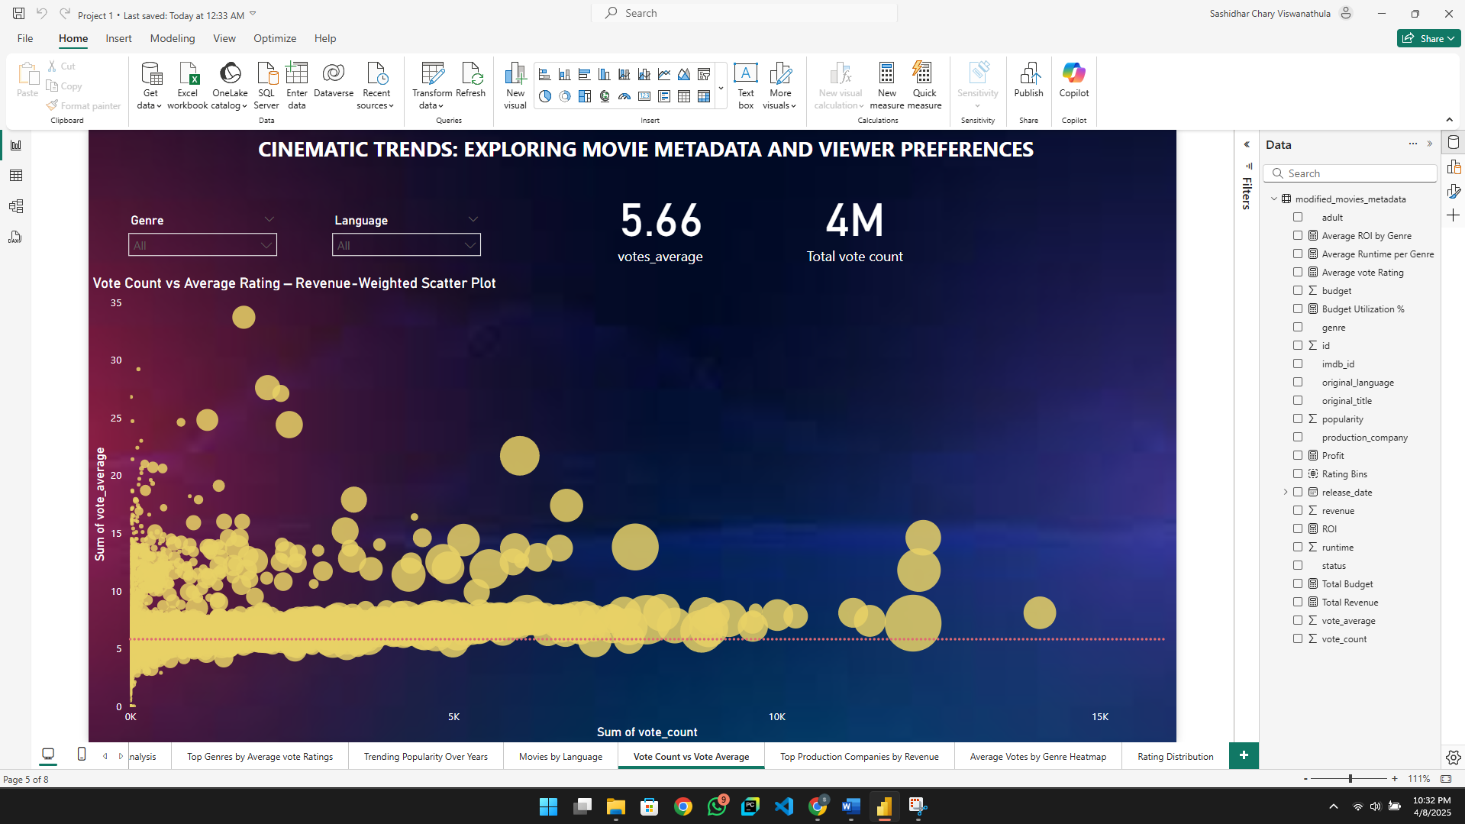

The above chart is a scatter plot on X axis we have sum of word count on Y axis we have sum of vote average bubble size is proportional to revenue. Disk slatter plot allows us to analyze three performance metrics simultaneously.

1. How many people voted for a movie?
2. How highly did those people rate the movie?
3. How much revenue does the movie make?

Visually we can observe that a majority of bubbles cluster around the mid lower Y axis indicating a concentration of average rated movies rating between five and 10. The horizontal spread of bubbles shows that some movies have very high vote counts exceeding 15,000 larger bubbles are generally on the right side which tells us the movies with more votes tend to generate modest revenue.

**Insights:**

By observing this scatterplot, we can say that high revenue is not equal to high ratings because many large bubbles are around the average rating 5 to 7. Success of a film lies in the mid rating but high vote count zone mainstream blockbusters that receive wide attention but average ratings high rating, low vote low revenue films suggest hidden gems or niche productions loved by a small but passionate audience.

**Visualization 6: TOP PRODUCTION COMPANIES BY REVENUE**

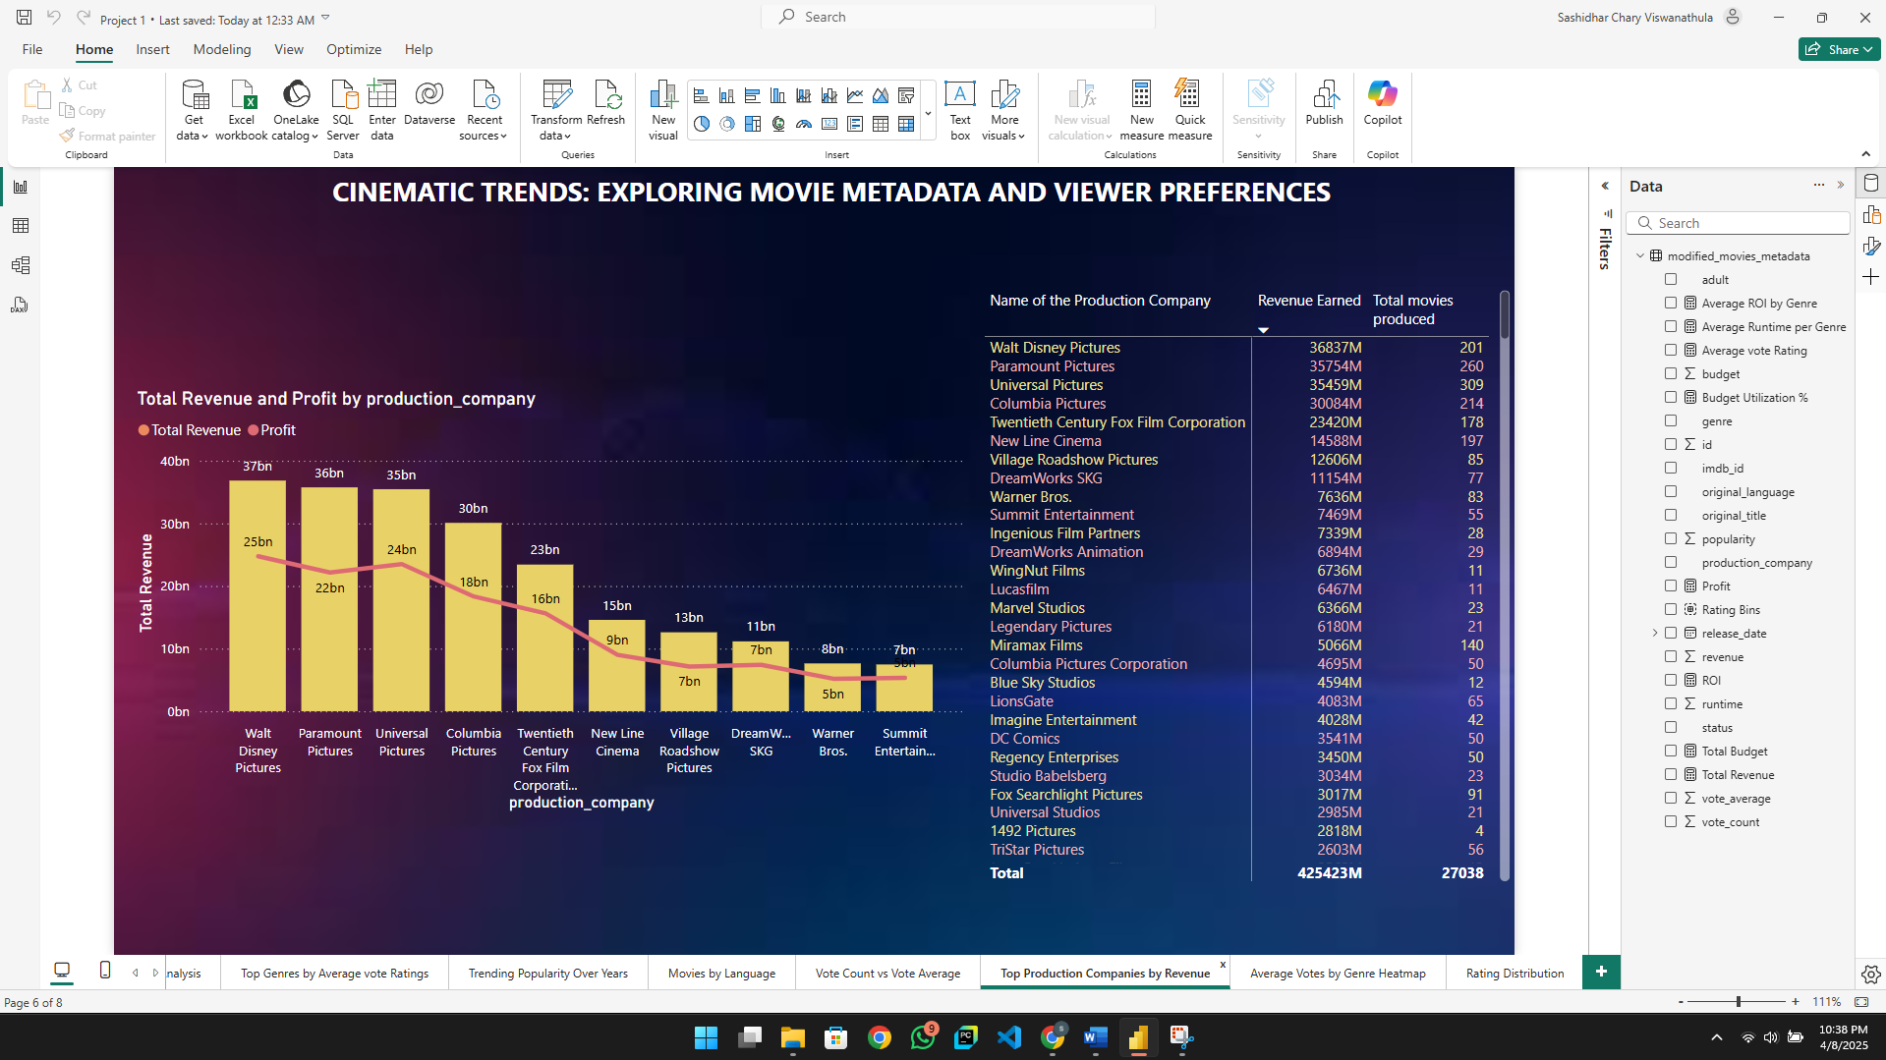

This visualization is a combination of bar and line chart. X axis we have production company on the Y axis we have total revenue, and the line indicates profit this chart compares revenue vs profit for top production companies. The table visualization has revenue earned in millions and total movies produced

The chart tells us Walt Disney Pictures has a revenue of 37 billion with a profit of 25 billion. By this we can say that Disney is the undisputed leader with strong margins and a large catalog of 201 movies. Paramount pictures and Universal pictures are two production companies whose revenue is close to Disney and profit is slight lower than Disney around 22 billion to 24 billion. which accounts for 260 plus movies from each production company. As a chart moves to the right side revenue and profit both decline but profit decreases more steeply than revenue for example Summit Entertainment and Warner Bros make 7 billion and 8 billion, with profits of one to 2 billion, suggesting higher costs or low ROI.

Matrix visualization adds important context by showing volume of production such as universal pictures leads in total movies of 39 dream works animation with fewer titles of 29 studios like Marvel Studios and legendary pictures appear mid table with fewer movies but relatively high revenues, showing quality over quantity success.

**Insights:**

By observing the whole visualization, we can say that Walt Disney’s dominance in both volume and profitability confirms its position as a market leader although there is a noticeable correlation between scale and success but not always fuse studios with small catalogs deliver strong returns companies with higher output but lower profits might need operational or content strategy adjustments.

**Visualization 7: GENRE-LANGUAGE HEATMAP**

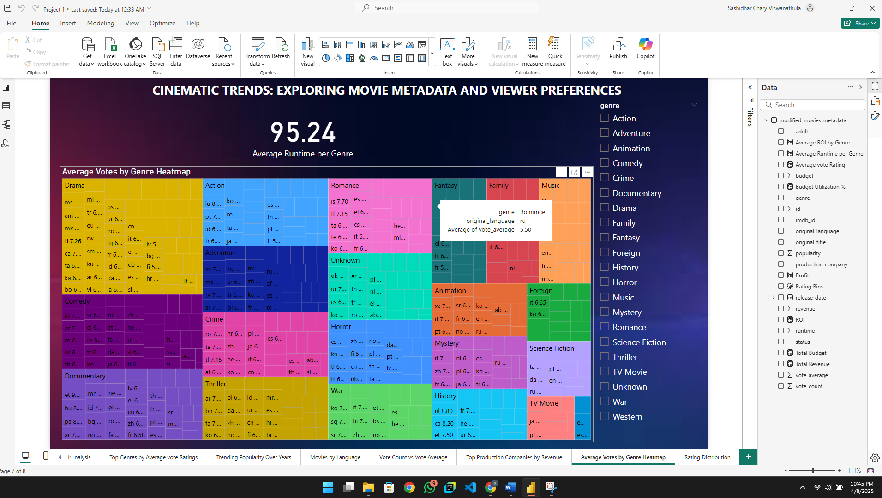

The above visualization is a heat map which shows average votes by genre. In category axis we have genre and original language, and the metric displayed here is voting average. This heat map is a multilayered analysis which shows how each genre performs in terms of audience rating and which original language versions of the genre received higher or lower ratings. Each small tile represents a unique combination of genre plus language and is proportional in size based on the number of titles and displays the average via rating for that combination.

**Insights:**

By observing the heat map, we can say that drama has the widest representation, indicating high volume and variety across languages like animation, foreign and documentary also show healthy ratings across multiple languages. For example, in the tool tip romance movies in Russian average a 5.5 rating which shows moderate performance foreign genre entries often hover above 6.5, showing strong audience appreciation for international cinema.

Some genres like TV movie horror tend to have lower ratings or fewer language variations. Crime thriller and mystery genres also display many language tiles with ratings close to the global average of 5.66.

**Visualization 8: RATING DISTRIBUTION**

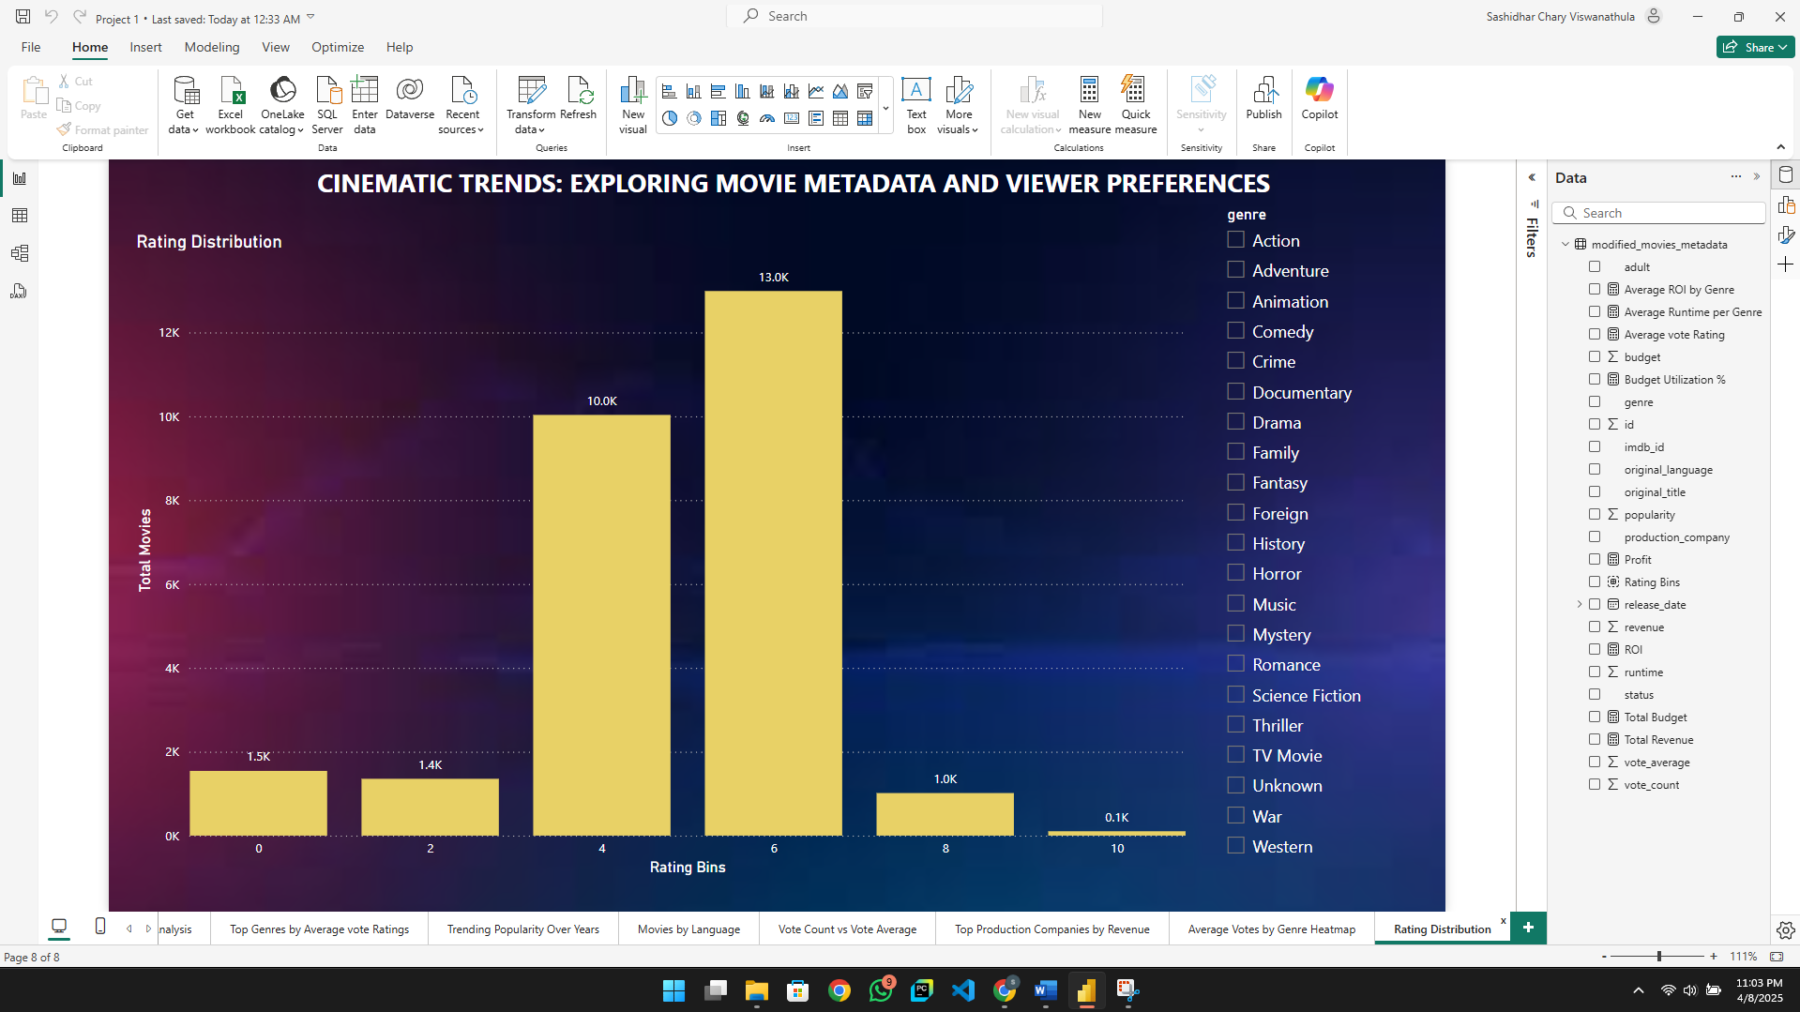

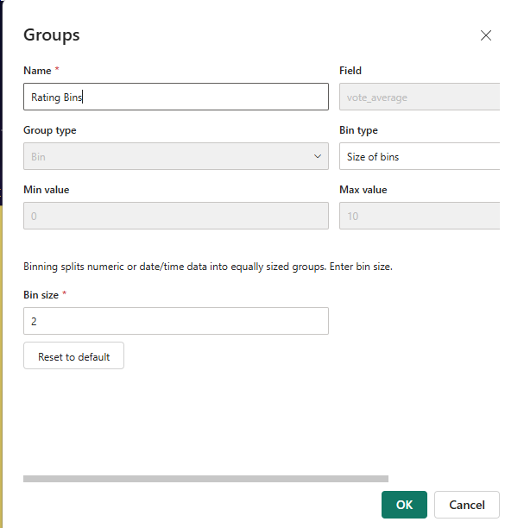

This visualization shows the rating distribution on the X axis we have ranges like 02468 and 10 on the Y axis we have the number of movies that fall into each rating bin. For this visualization I’ve binned the vote average field with the size of two, ranging from 0 to 10. The rating buckets are 0-2,2-4,4 -6, 6 - 8, 8 - 10 and exactly 10.

**Insights:**

By observing the chart, most movies are rated between 4 to 8, which captures 23,000 of the total movies out of 27,000. Specifically, 6 to 8 range is the peak, with 13,000 movies rated here. Is also strong with 1000 entries. Only 1000 movies scored between 8 to 10 and even fewer 100 hit a percent score of 10. Similarly, only 1500 scored between zero to two indicating few movies are universally disliked. Ratings show a bell-shaped distribution towards the center.

**Storytelling Approach:**

**Stage 1: understanding and Exploring the Dataset:**

**What does raw data look like?**

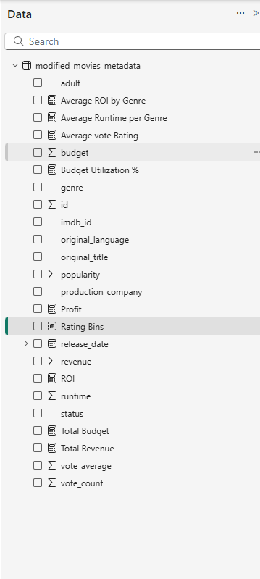

The dataset, as seen in the Fields pane, is from a table called modified_movies_metadata. It contains attributes such as:

**Identifiers:** id, original_title, imdb_id

**Descriptive:** genre, original_language, production_company

**Performance metrics:** budget, revenue, vote_average, vote_count, runtime, ROI, Profit, Budget Utilization %

**Calculated fields:** Average ROI by Genre, Rating Bins, etc.

**What key variables and trends stand out?**

**Revenue & Profit Trends:** Movies have consistently generated strong profits, with a total revenue of 425bn and profit of 255bn. Walt Disney, Paramount, and Universal are the top earners.

**Viewer Sentiment:** Average rating is 5.66 across 27,038 movies. Majority of movies fall in the 6-8 rating bin, indicating a large volume of moderately liked content. Animation, Music, and History genres received the highest ratings.

**Language & Genre:** English (69.9%) dominates, but foreign-language films also show strong niche performance.Performance of genres varies by language. e.g., Romance in Russian vs. Comedy in Korean.

**Viewer Engagement:** Vote count peaked around 2014-2018 and dropped off in 2020 (likely due to pandemic).High vote count doesn’t always equal high ratings, popularity and quality are not strictly correlated.

**Stage 2: Data Processing and Correlation Analysis**

In this stage, we move from descriptive analysis to uncovering underlying patterns and relationships between variables. Key operations include:

* Cleaning missing or inconsistent values
* Merging rating and metadata tables
* Creating new fields (e.g., Rating Bins, ROI, Profit)
* Grouping and binning numeric fields for trend analysis

**Correlation Analysis:**

**Vote Count vs Rating vs Revenue (Bubble Chart):** High revenue movies often lie in the mid-rating zone (5–7), not necessarily the highest-rated.Some well-rated movies have low vote counts, revealing undiscovered gems.

**Genre vs Average Rating:** Top genres in ratings: Animation, Music, History**.** Bottom genres: TV Movie, Horror. Supports genre-based content curation or investment strategies.

**Runtime vs Rating:** Longer movies may have better storytelling and thus higher ratings. To be validated in later phases with scatter or trend lines.

**Production Companies: Revenue vs Profit:** Walt Disney leads with high revenue and profit efficiency.Marvel Studios shows high ROI with fewer productions.Smaller companies tend to have lower revenue-per-movie.

Phase 2:

Cinematic Trends – Building an Interactive Dashboard for Movie Analytics

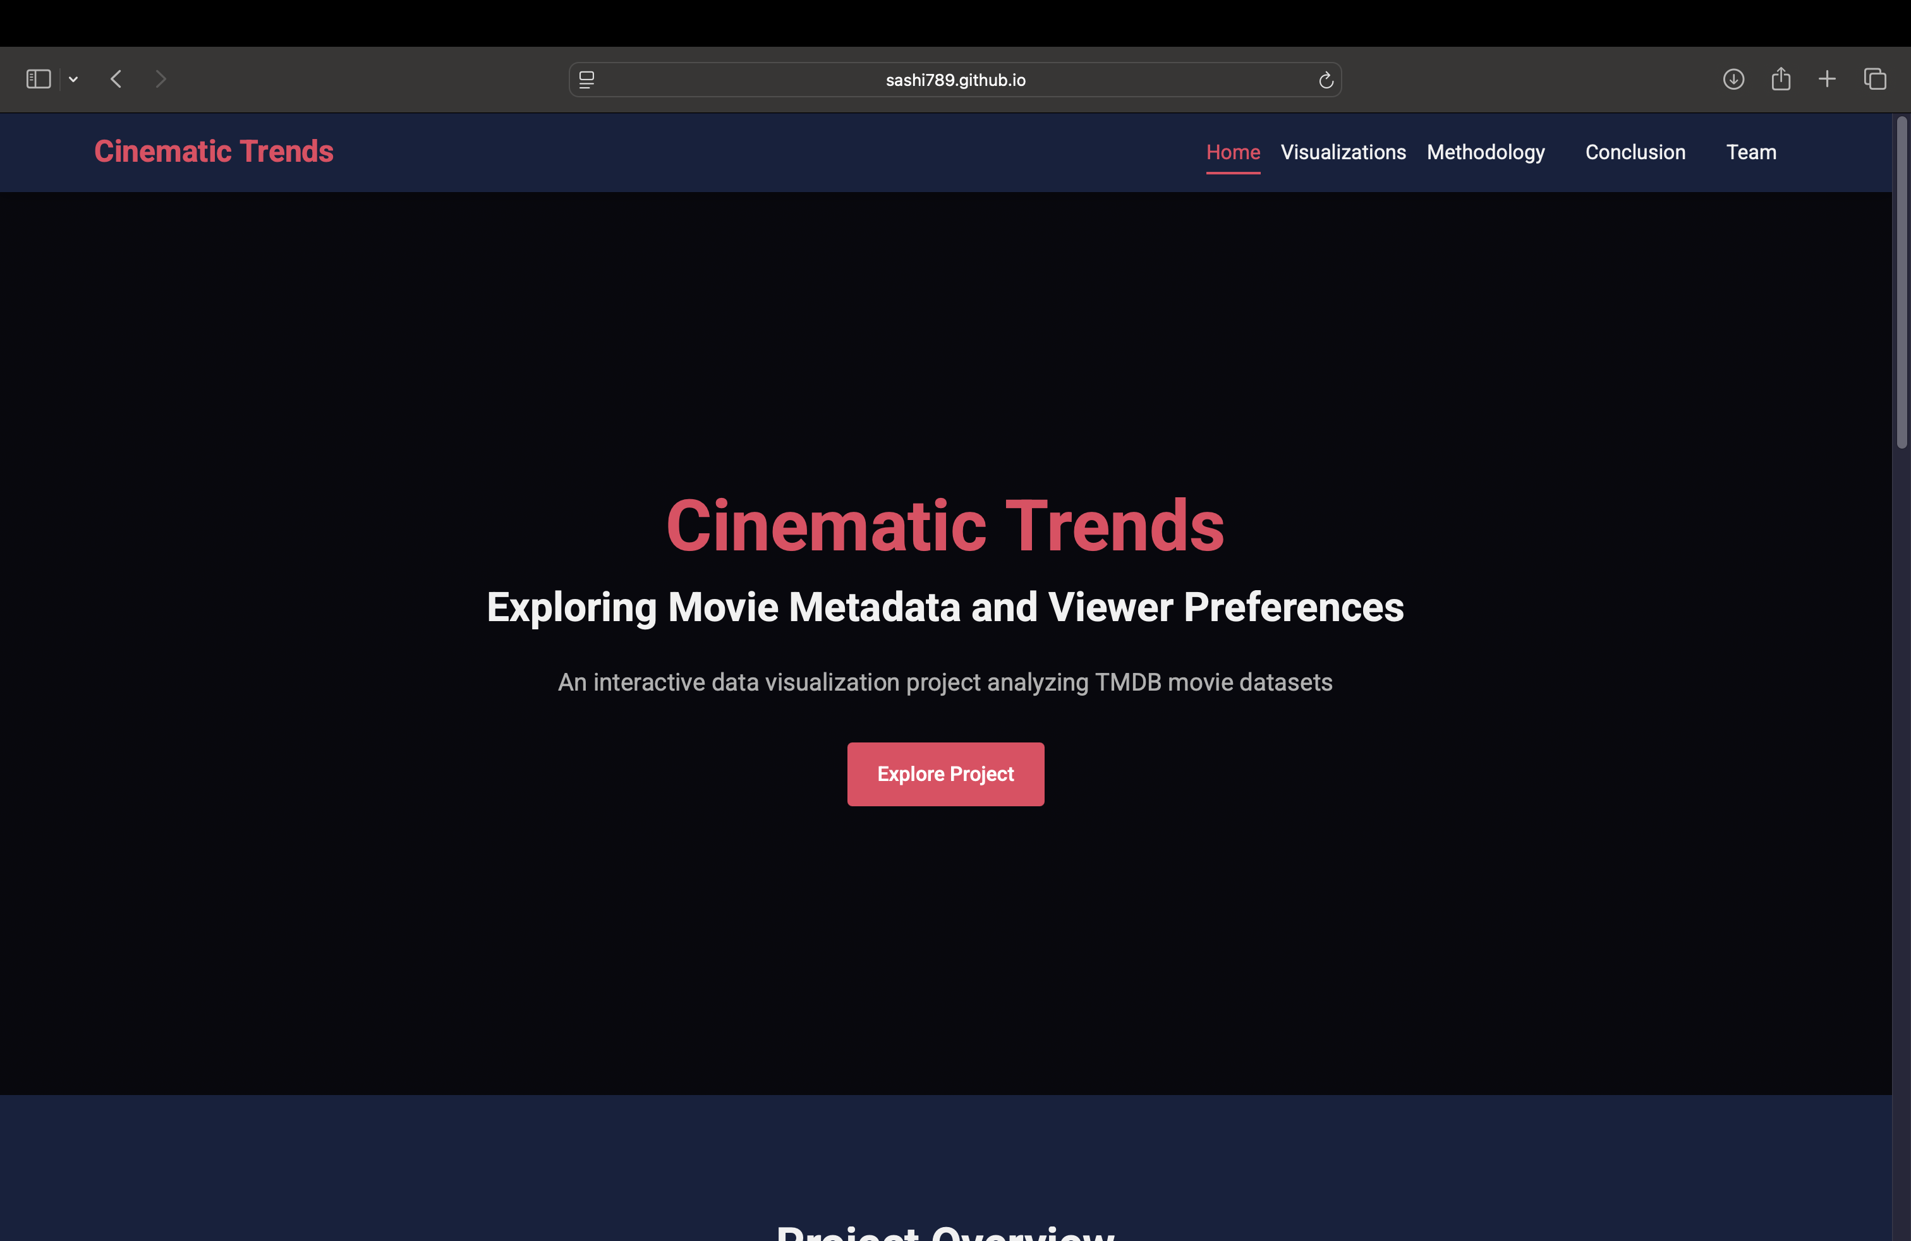

**CSS Styling (responsive.css and style.css):**  
We designed the website layout and appearance using two main CSS files:

* style.css handles the global styles, color themes, typography, and layout structure.
* responsive.css ensures the dashboard is fully responsive across devices by adjusting the layout for different screen sizes.

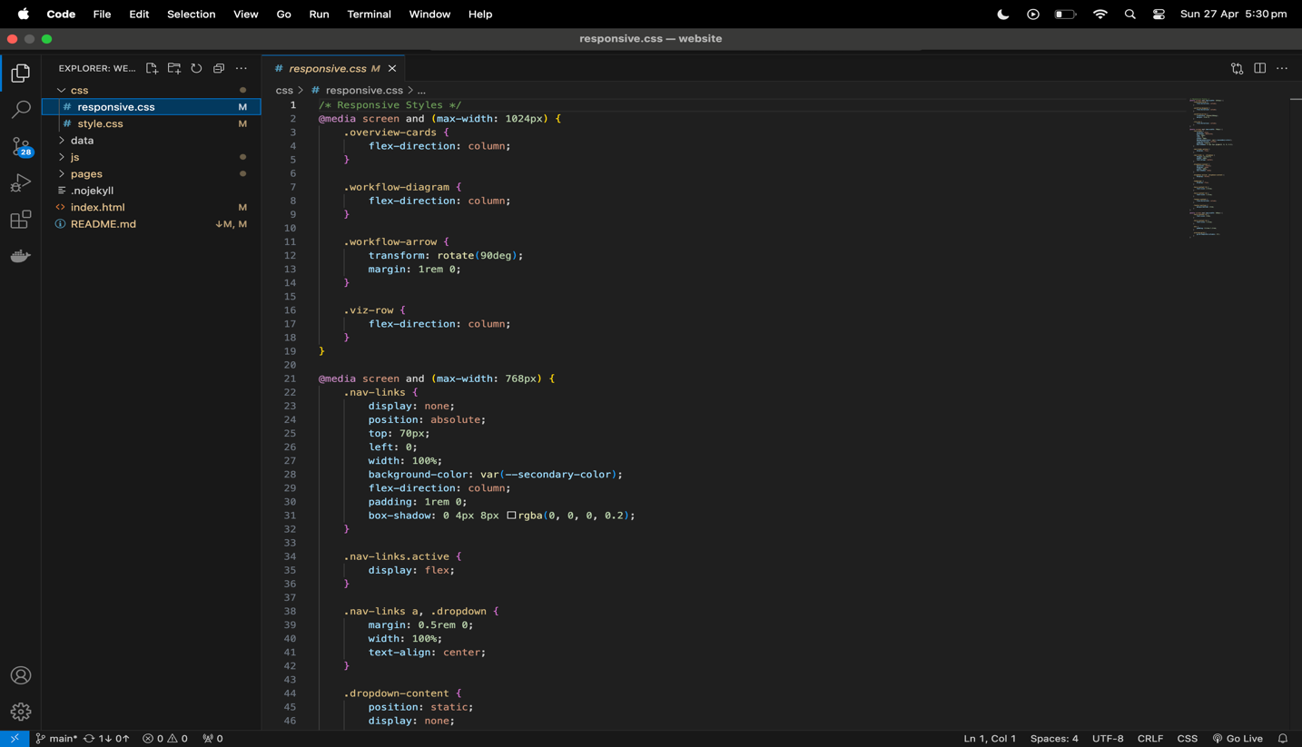

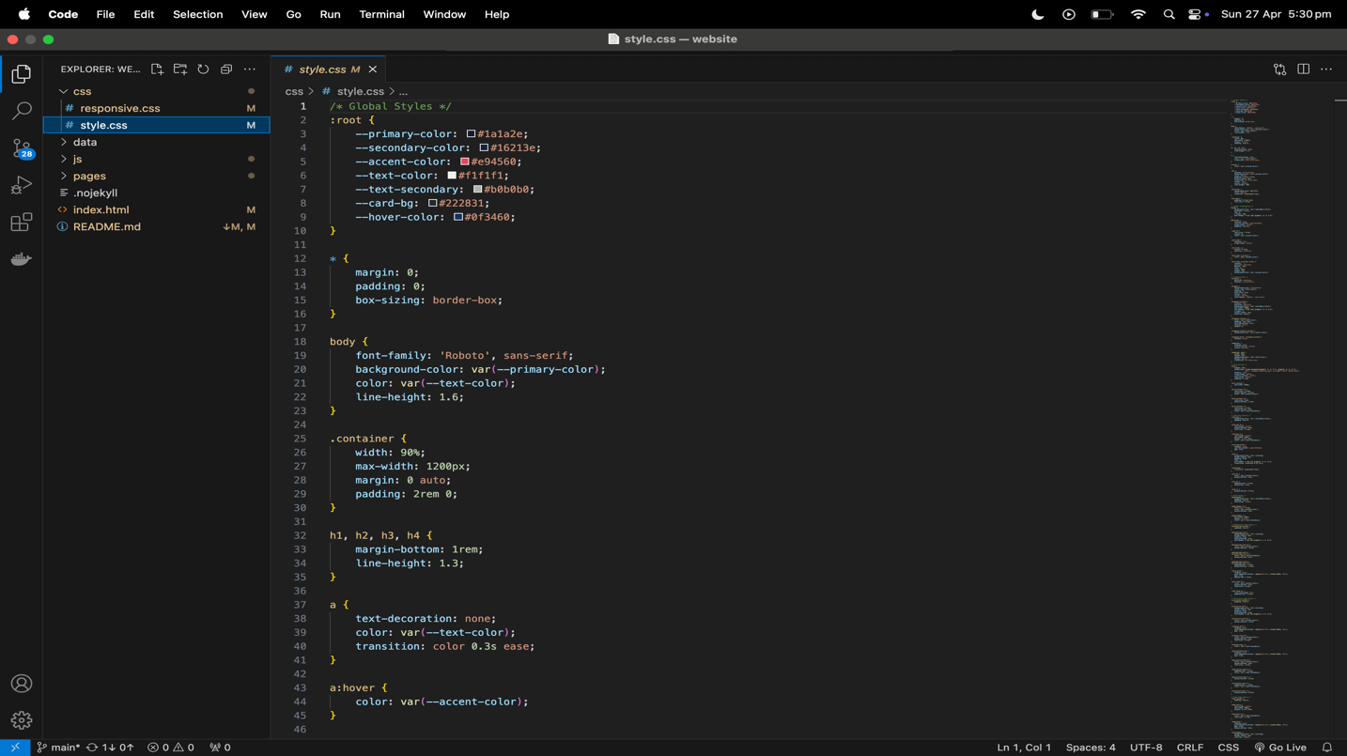

**Dataset Preparation (movies_data.csv):**  
This file represents the final merged dataset combining **movies metadata** and **user ratings**.  
It was created after cleaning, preprocessing, and joining the original Kaggle datasets to enable comprehensive analysis.

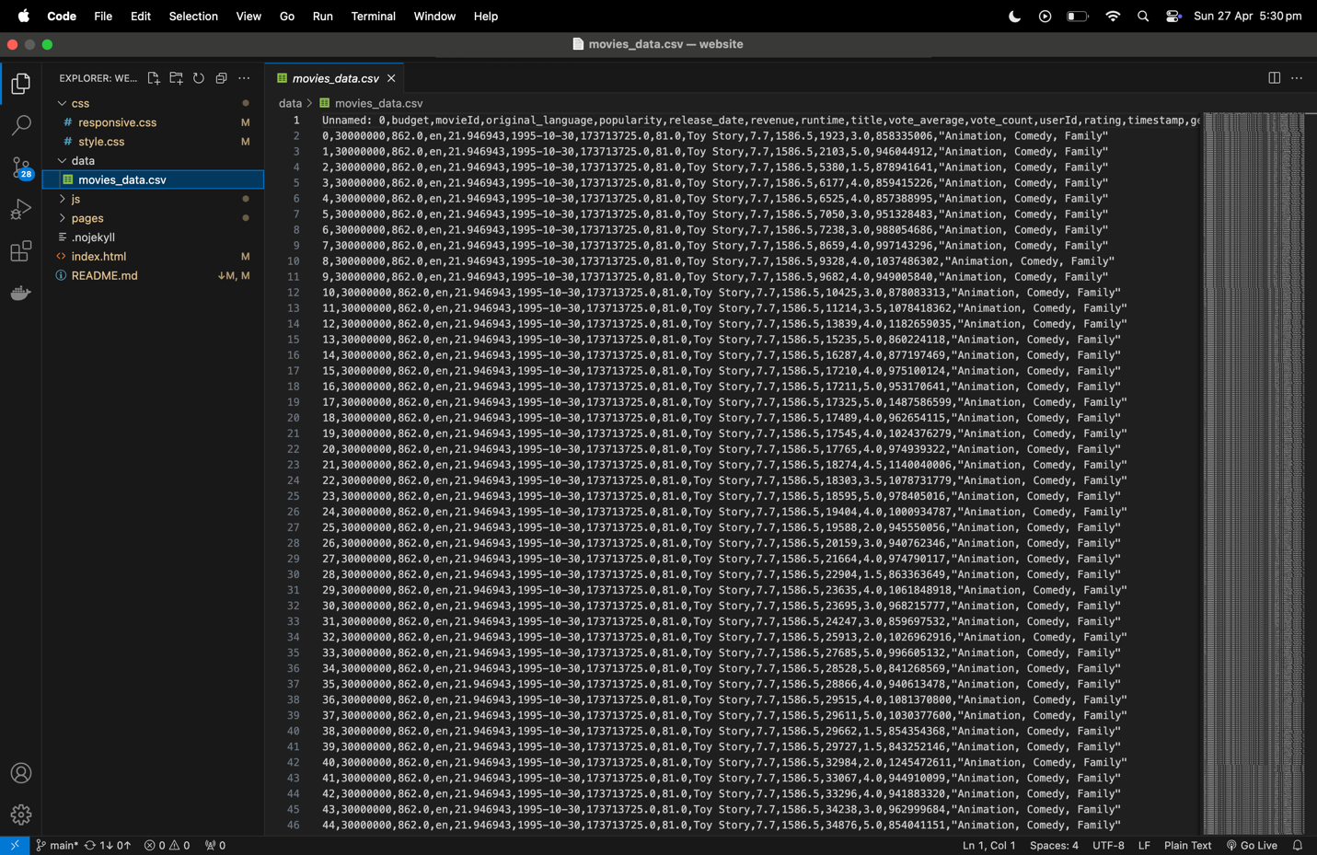

**Interactive Visualizations (JavaScript Files):**  
Custom interactive visualizations were created using:

* interactive-visualizations.js for overall event handling and chart rendering.
* Specific visualization scripts like language-popularity.js, genre-ratings.js, etc., to generate different interactive dashboards.
* Libraries used include **D3.js**, **Plotly.js**, and **Vega-Lite** for dynamic chart generation.

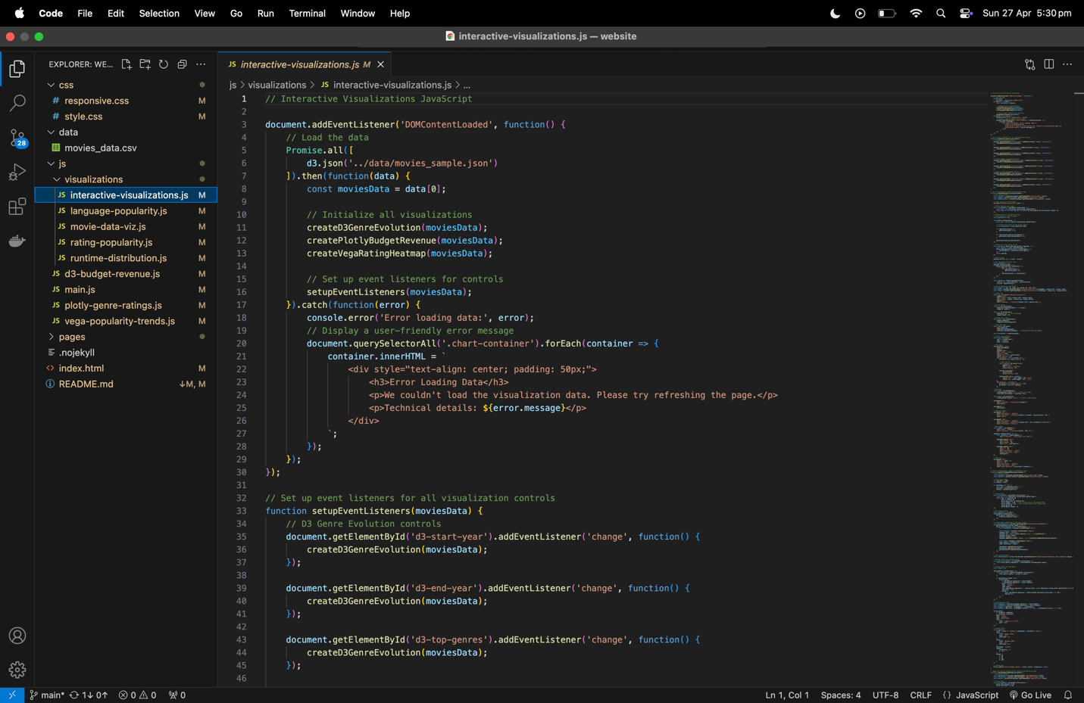

**Web Structure (index.html and Other HTML Files)**  
The index.html file organizes the website structure, including:

* Navigation menu
* Linking CSS/JS files
* Embedding visualization pages Each analysis section like "Revenue vs Budget," "Trending Popularity," etc., is structured into individual HTML files under the pages/ directory.

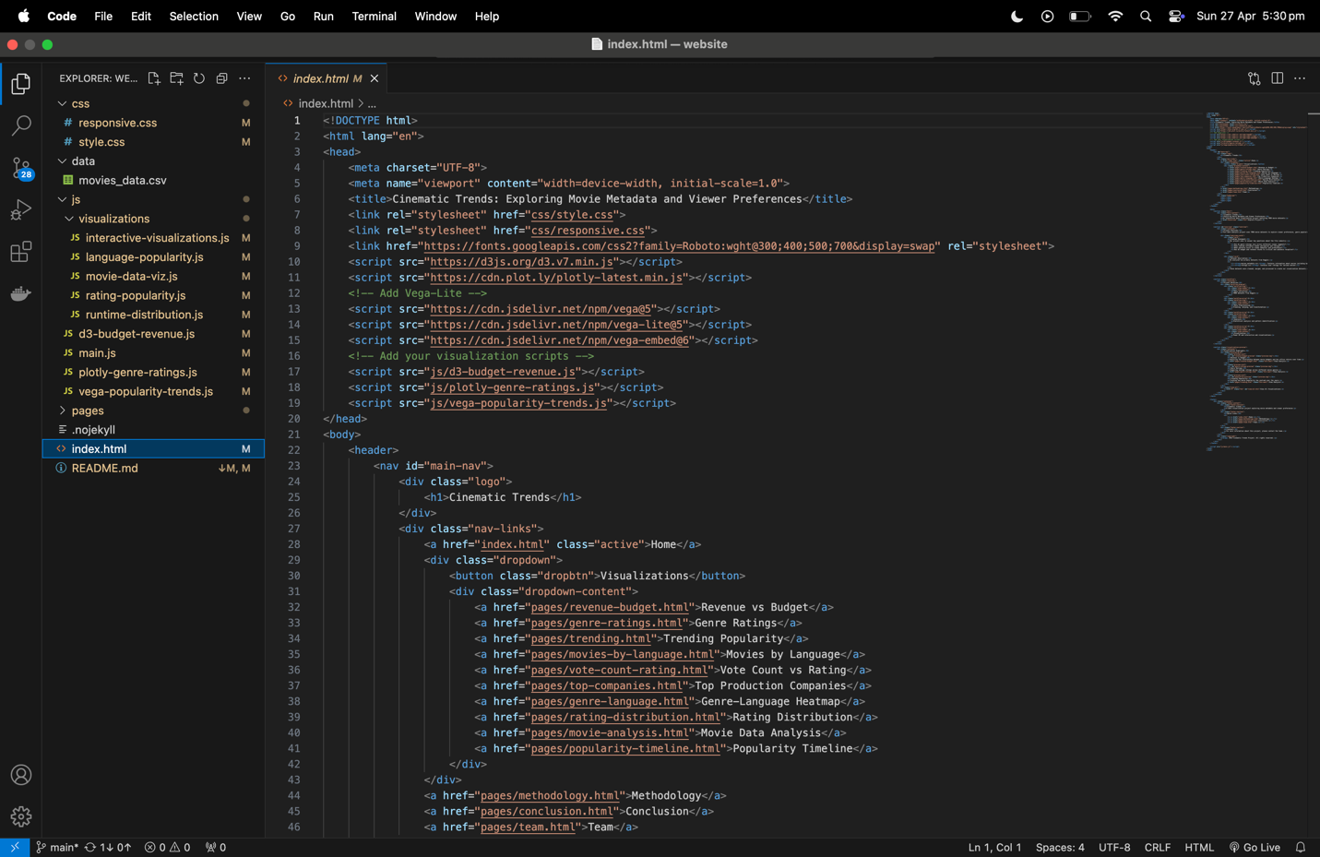

**Documentation (README.md)**  
The README.md file provides a project overview, listing the technologies used and describing the main features, visualizations, and goals of the project.  
It serves as a guide for users and collaborators visiting the GitHub repository.

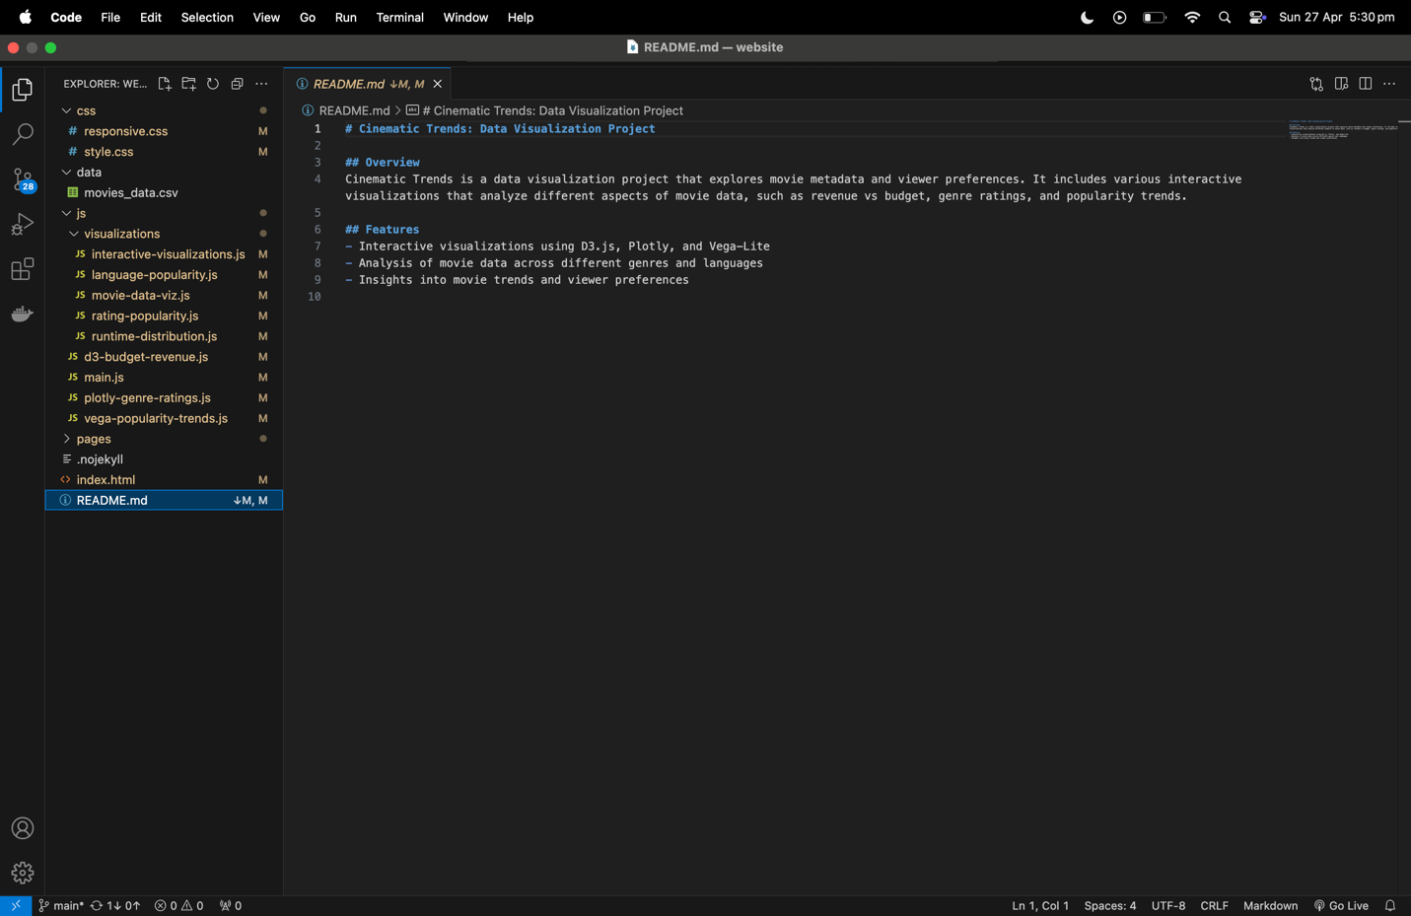

**Website Overview:**

* We developed an interactive website named *Cinematic Trends* to explore movie metadata and viewer preferences through dynamic, embedded visualizations. The site is structured with sections such as Home, Visualizations, Methodology, Conclusion, and Team
* The website provides multiple interactive visualizations focused on analyzing key cinematic metrics such as Revenue vs Budget, Genre Ratings, Trending Popularity, and more. Each visualization offers dynamic filtering and deeper exploration options.
* Website Link: <https://github.com/sashi789/SDV_project>

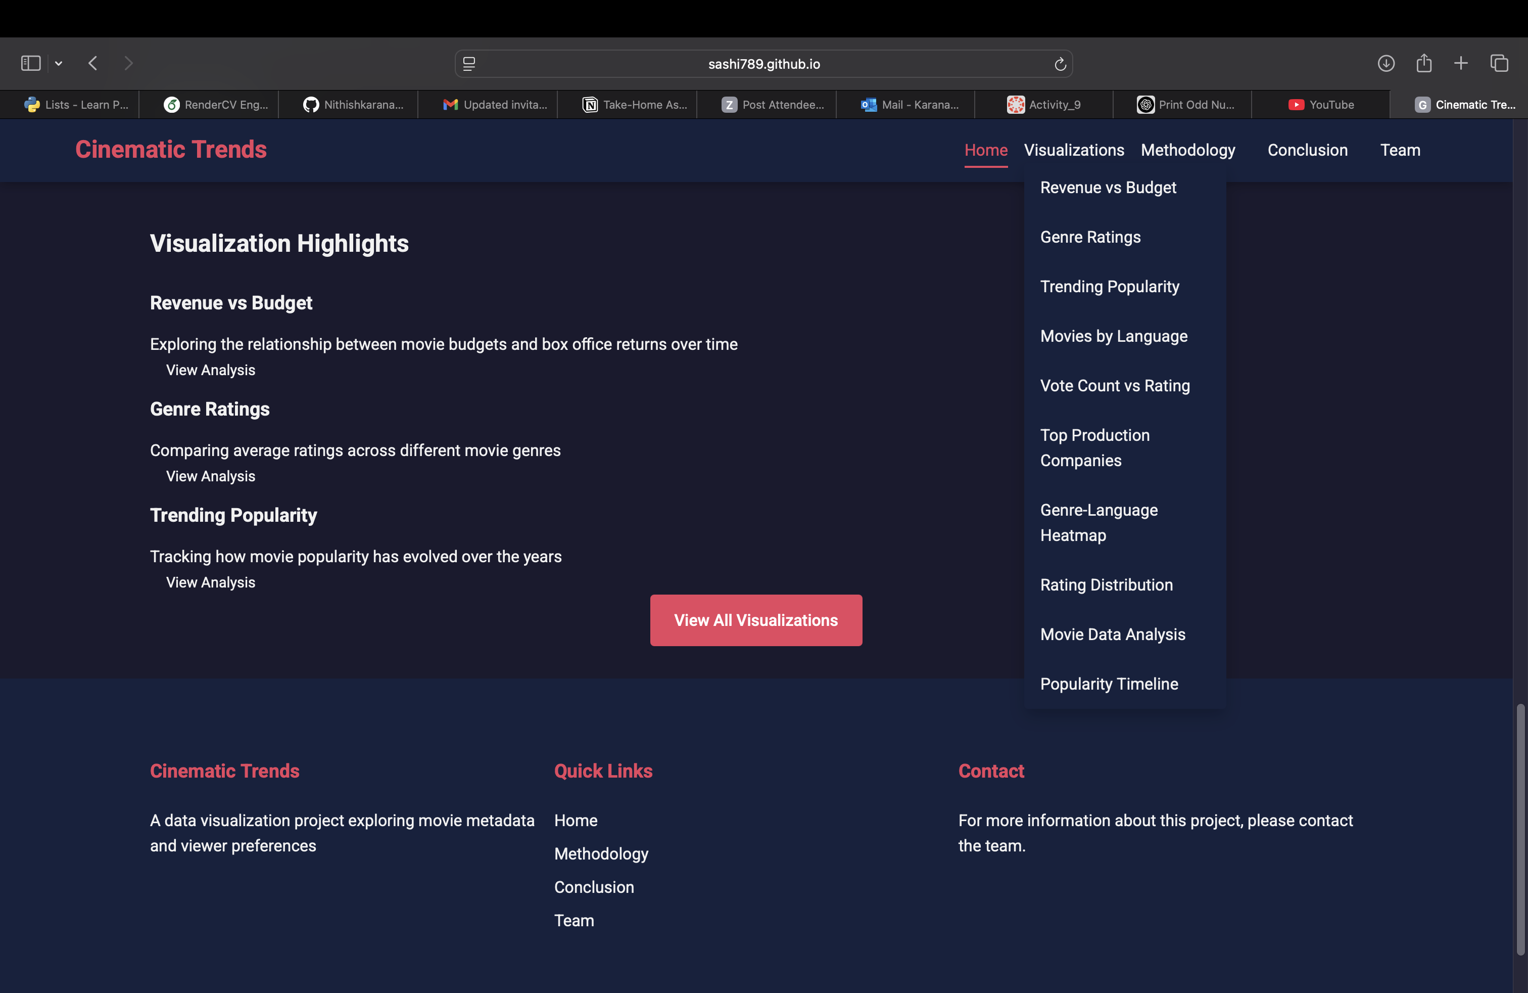

**Dashboard View: Revenue vs Budget Analysis:**

* In this dashboard, we explore the financial relationship between movie production budgets and their corresponding box office revenues.
* Users can interactively filter the data by **year** and **genre**, enabling deeper exploration of specific trends over time.  
  The visualization provides a dynamic scatter plot that reveals clusters of financially successful films and helps identify outliers with high budgets but low returns.
* By embedding this analysis into the Cinematic Trends website, we allow users to intuitively understand how budget allocations have historically influenced financial performance in the movie industry.

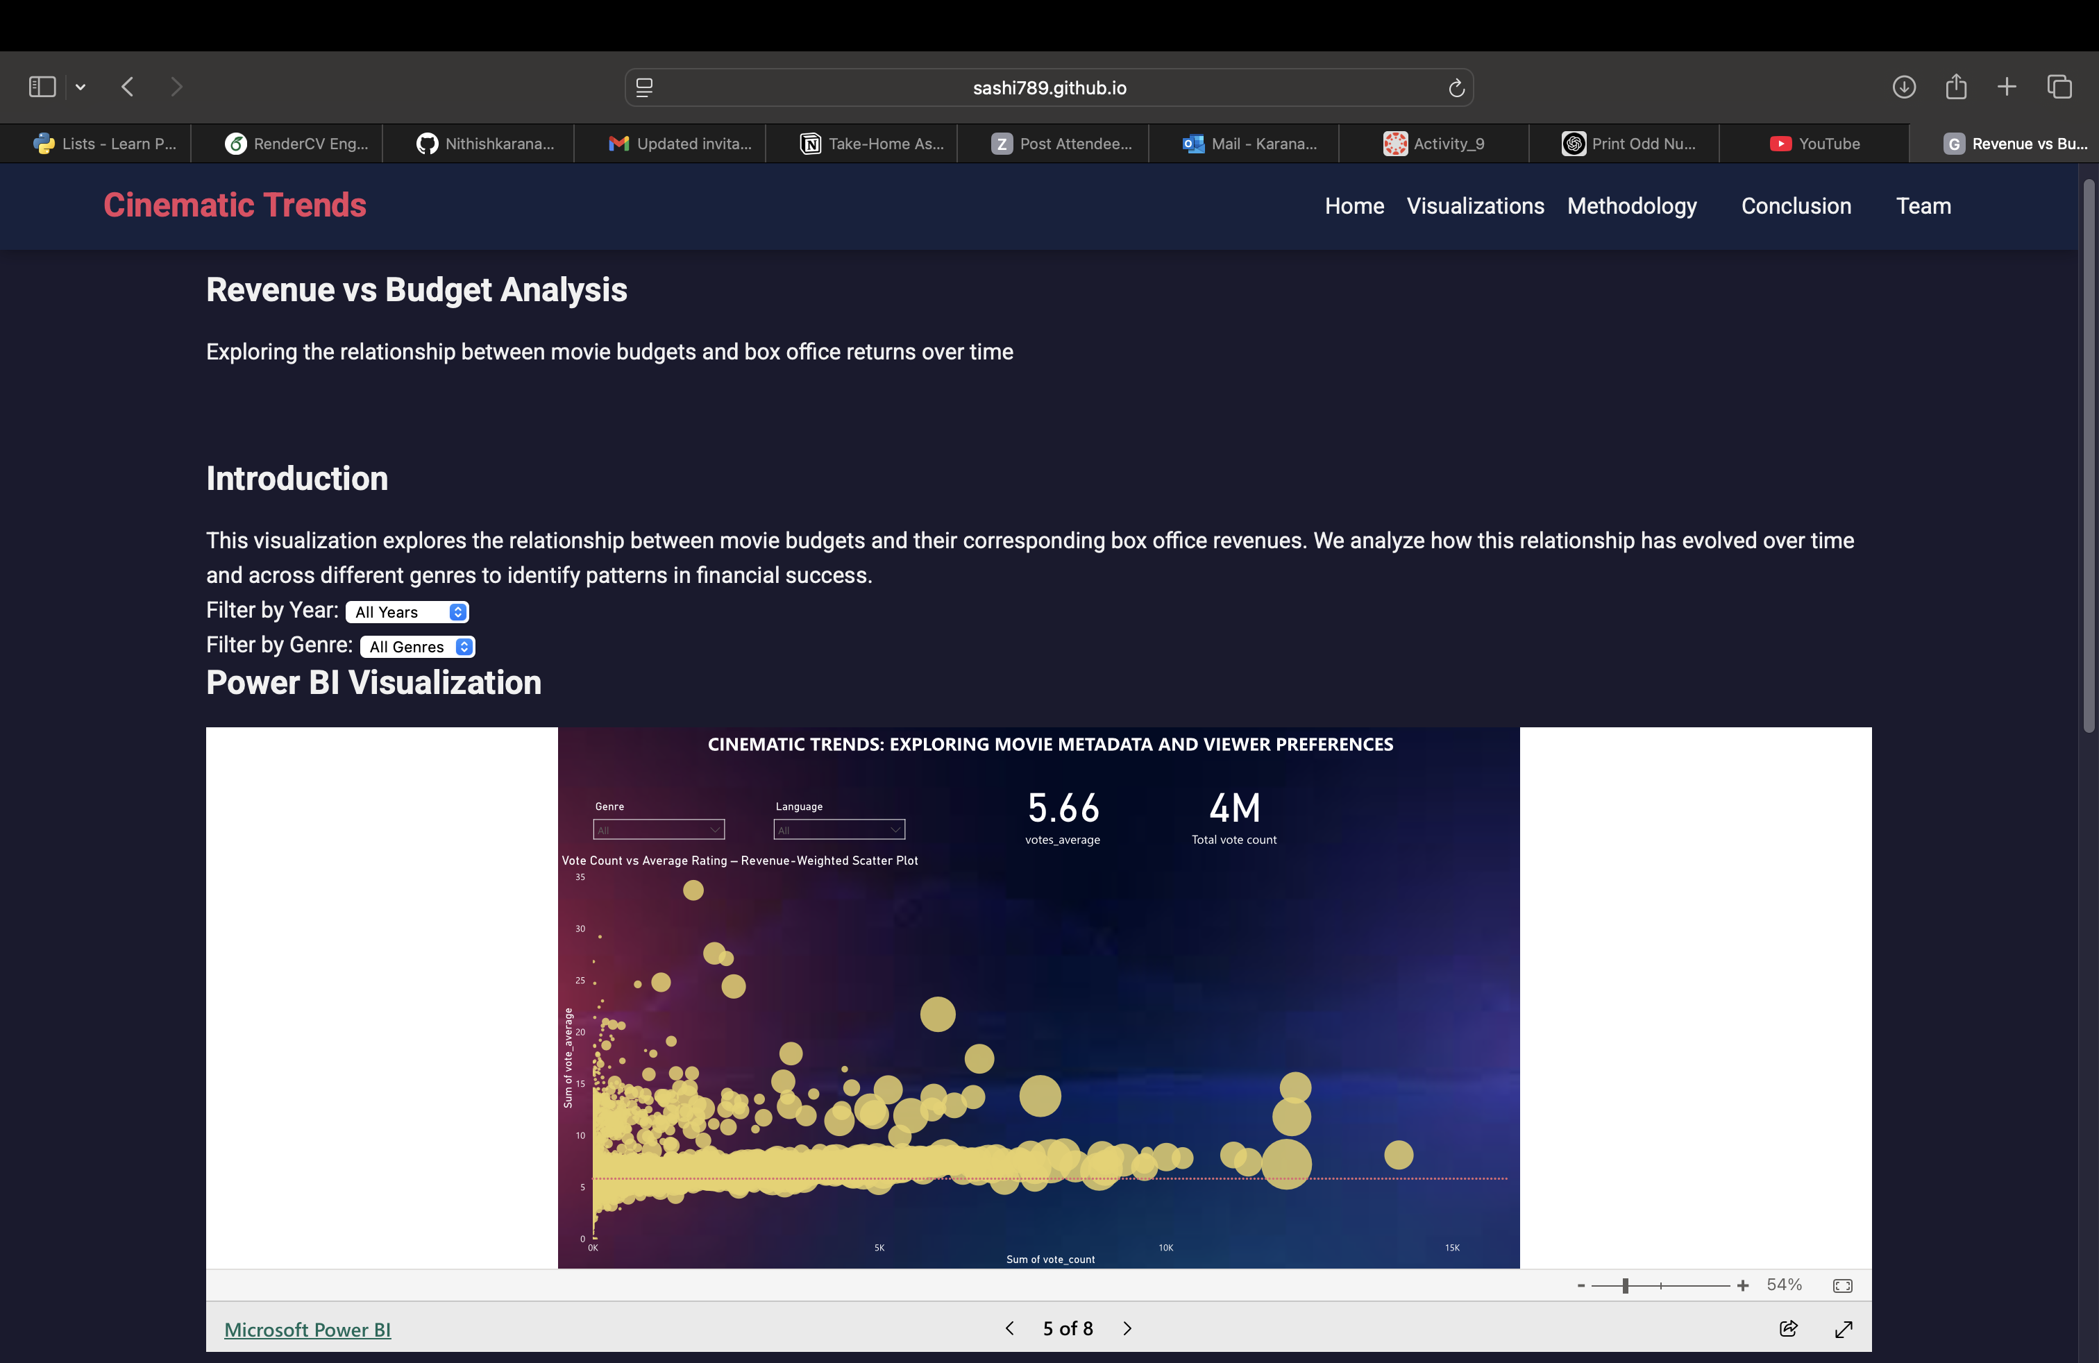

**Dashboard View: Genre Ratings Analysis**

* This interactive dashboard analyzes the average viewer ratings across different movie genres.  
  Users can dynamically filter by **year**, **language**, and **production company** to observe how audience preferences change over time or across regions.
* The visualization helps identify which genres consistently receive high ratings and which ones underperform, offering valuable insights into audience sentiment and genre popularity.
* Embedding this analysis within the Cinematic Trends website allows users to explore genre-specific performance patterns in a user-friendly, visual format.

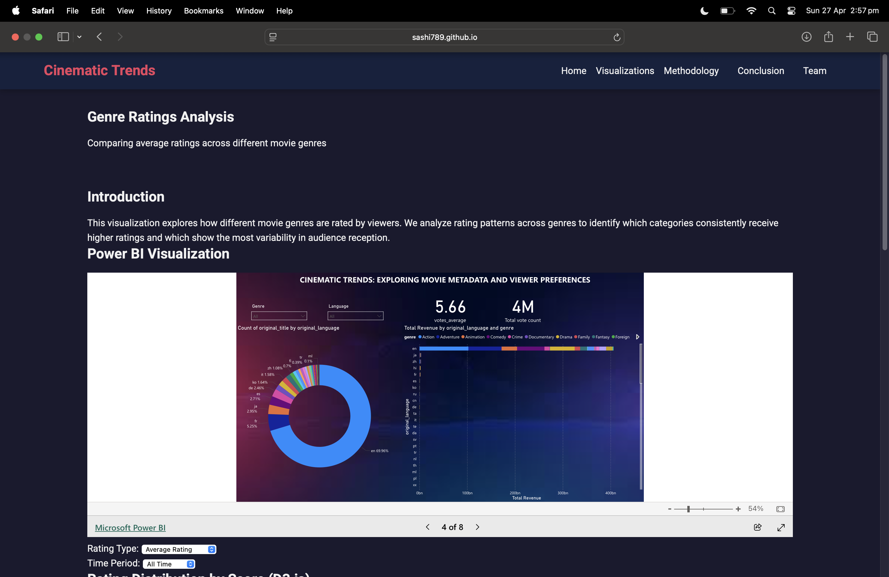

**Dashboard View: Trending Popularity Analysis**

* This dashboard visualizes the changing popularity of movies over time based on viewer engagement metrics, such as vote counts.
* Users can interactively filter the data by **genre** and **language** to explore how popularity trends differ across categories and regions.
* The visualization highlights key periods of increased viewer activity, such as the rise of streaming platforms, and also reflects major disruptions like the COVID-19 pandemic.
* By embedding this visualization within the Cinematic Trends website, users can intuitively analyze historical audience behavior and discover how external factors have influenced movie popularity over the decades.

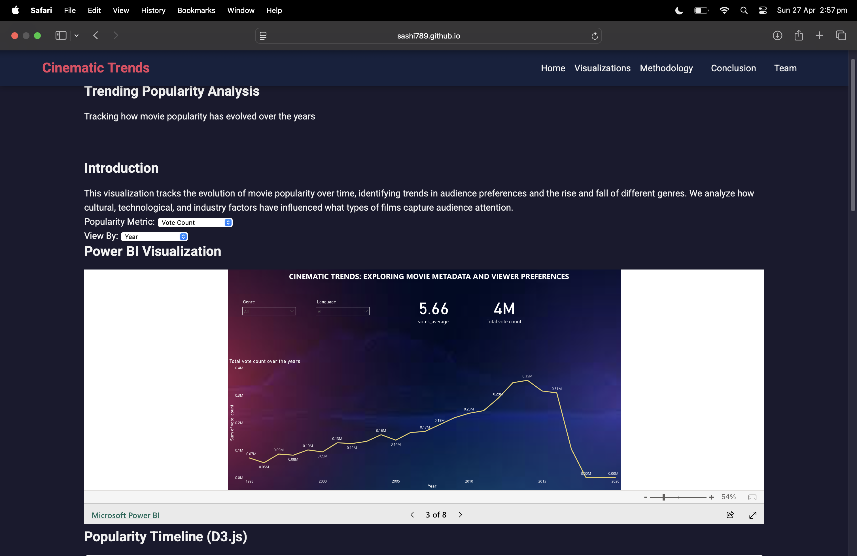

**Dashboard View: Movies by Language**

* This dashboard explores the distribution of movies based on their original production languages.
* Users can view the number of movies produced in each language, as well as key performance metrics such as **average rating** and **total vote count** for each language group.
* The visualization reveals the dominance of English-language films while also highlighting the significant contributions of other languages like Hindi, French, Japanese, and Spanish to the global cinema landscape.
* Embedding this analysis within the Cinematic Trends website provides users with an intuitive understanding of global film production diversity and regional audience reach.

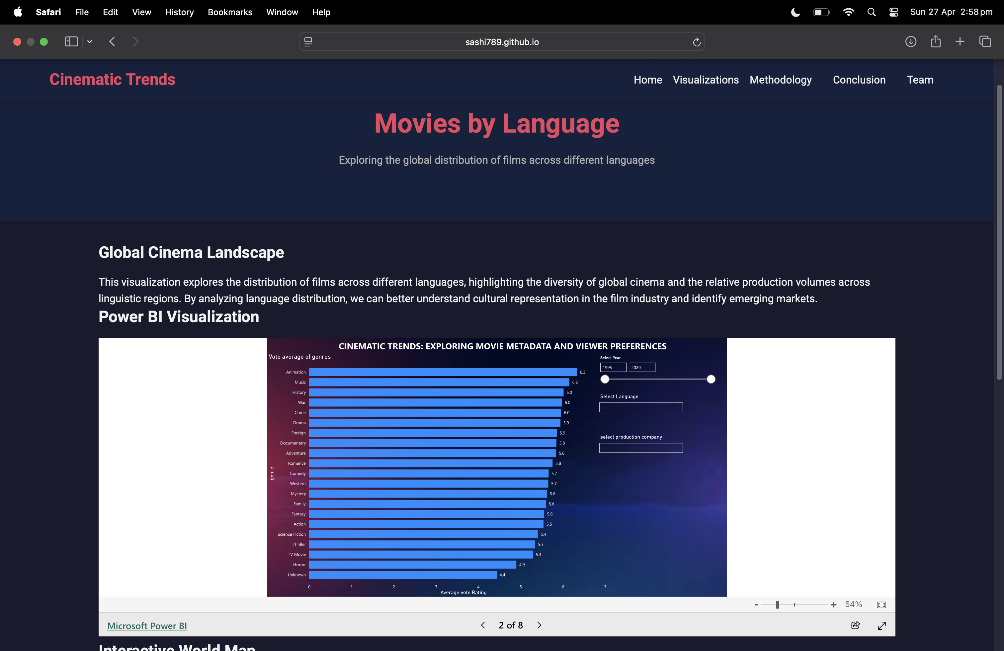

Dashboard View: Vote Count vs Rating Analysis

* This interactive dashboard analyzes the relationship between the number of audience votes a movie receives and its average rating.
* It helps uncover trends such as whether highly rated movies attract more votes, or whether popular movies often have average ratings.
* Users can explore how vote volume and critical reception align across different genres and languages, providing insight into audience engagement versus perceived quality.
* Embedding this visualization on the Cinematic Trends website enables a deeper understanding of how audience size correlates with movie success metrics.

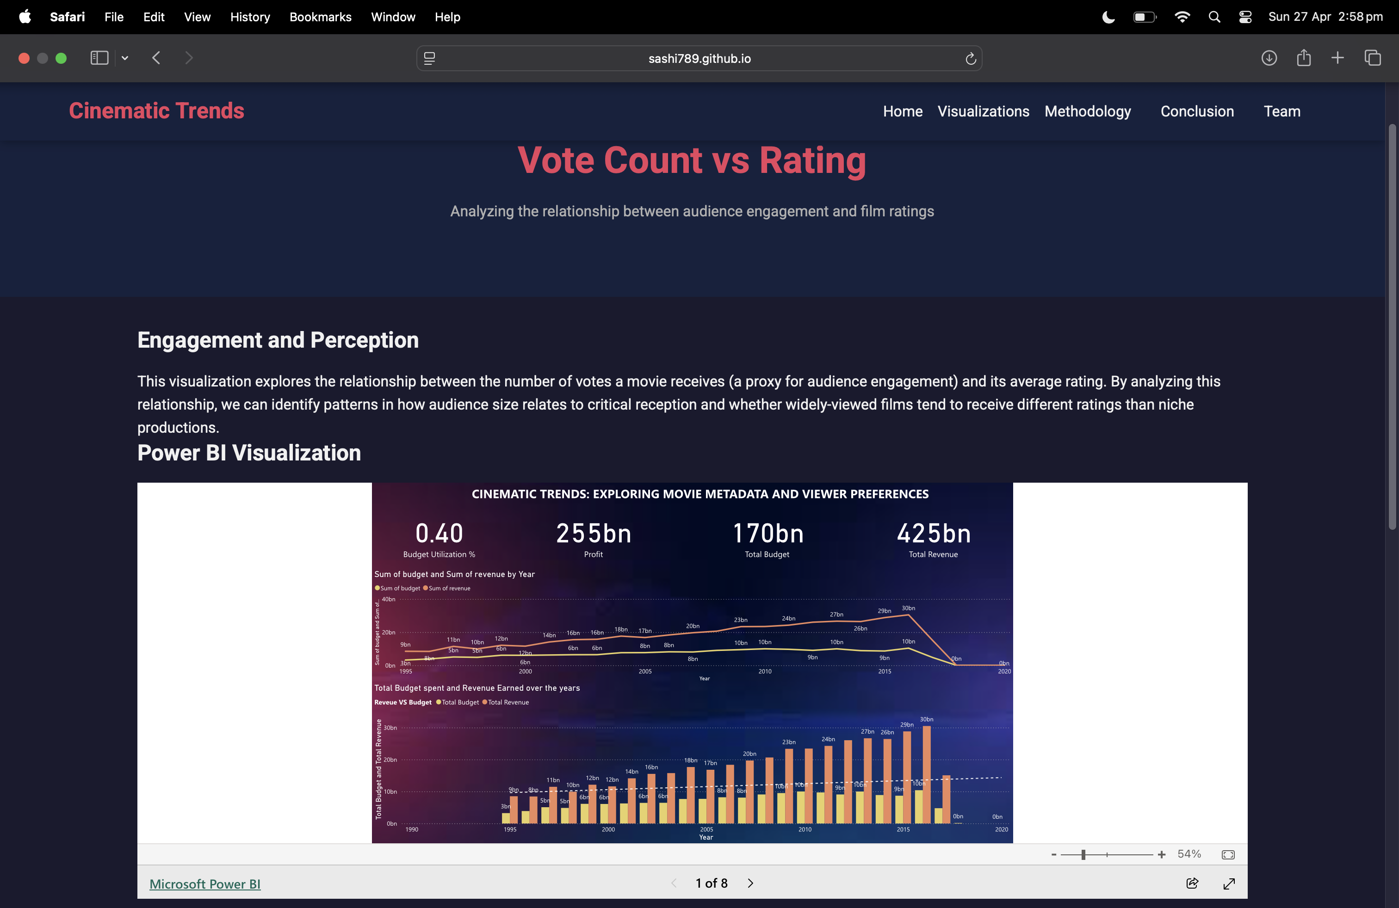

Dashboard View: Top Production Companies

* This dashboard ranks the top production companies based on their total movie revenue and profits.
* Users can compare studios like Disney, Universal, and Paramount to understand differences in financial performance and production volume.
* The visualization reveals which companies consistently deliver high revenue films, and highlights strategic differences between studios focusing on quantity versus quality.

Embedded within the Cinematic Trends website, it offers users an industry-wide perspective on financial success and production strategies

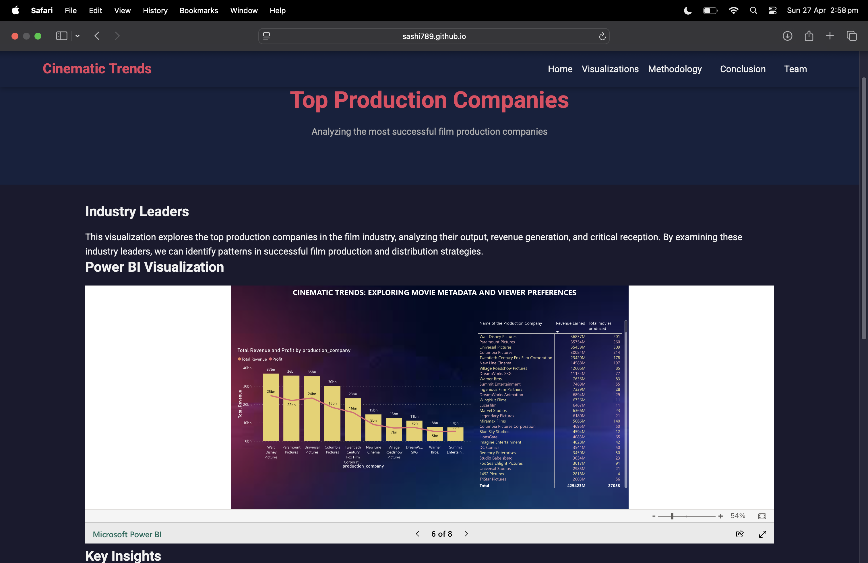

Dashboard View: Genre-Language Heatmap

* This heatmap explores how different movie genres perform across various languages in terms of average ratings.
* Each cell represents a genre-language combination, allowing users to discover cultural preferences and rating patterns across global cinema.
* It highlights genres that perform strongly across multiple languages (such as Animation and Documentary) and those that vary significantly based on cultural factors.
* Embedding this multilayered visualization enhances user exploration of cross-cultural genre success on the Cinematic Trends website.

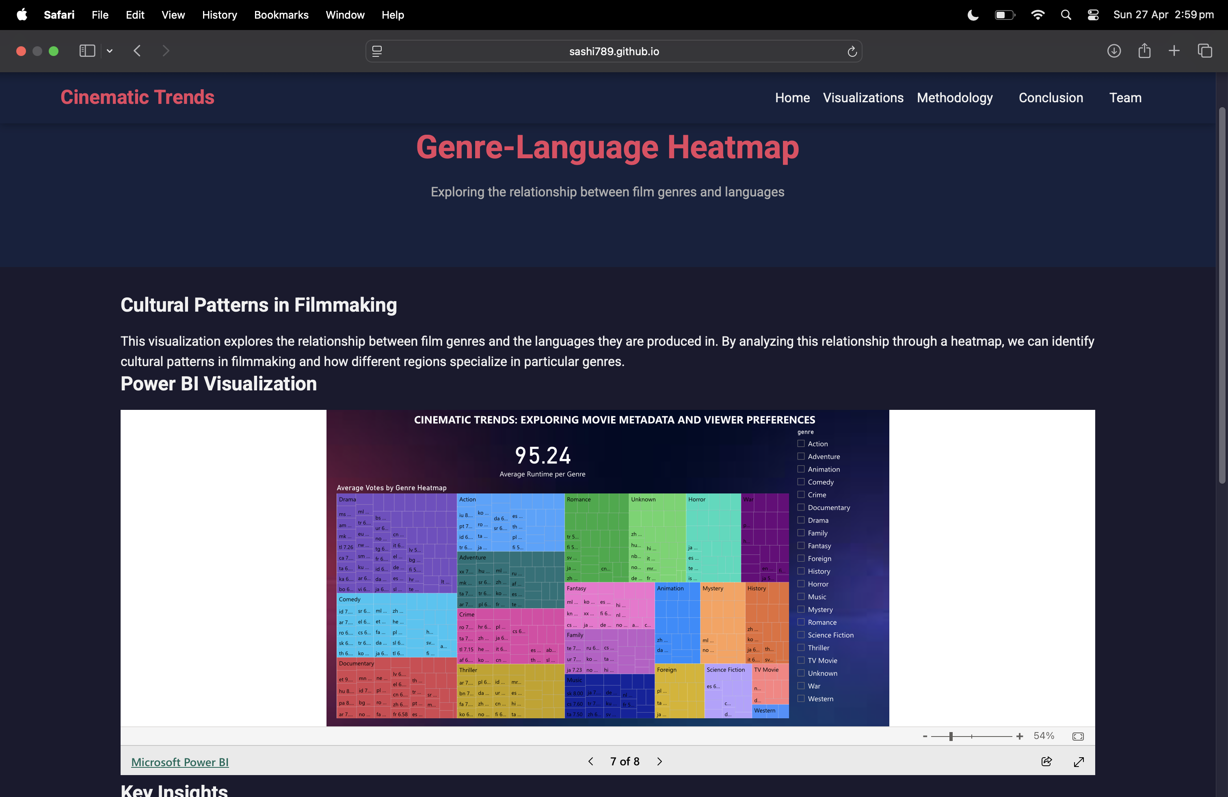

Dashboard View: Rating Distribution

* This dashboard visualizes the distribution of movie ratings across defined rating bins (e.g., 0–2, 2–4, 4–6, etc.).
* It shows how most movies cluster around average ratings, while very high-rated or very low-rated movies are rare.
* This helps users understand overall audience scoring behavior and identify trends like the bell-shaped (normal) distribution of ratings.
* Hosted on the Cinematic Trends website, this dashboard makes exploring rating patterns intuitive and interactive.

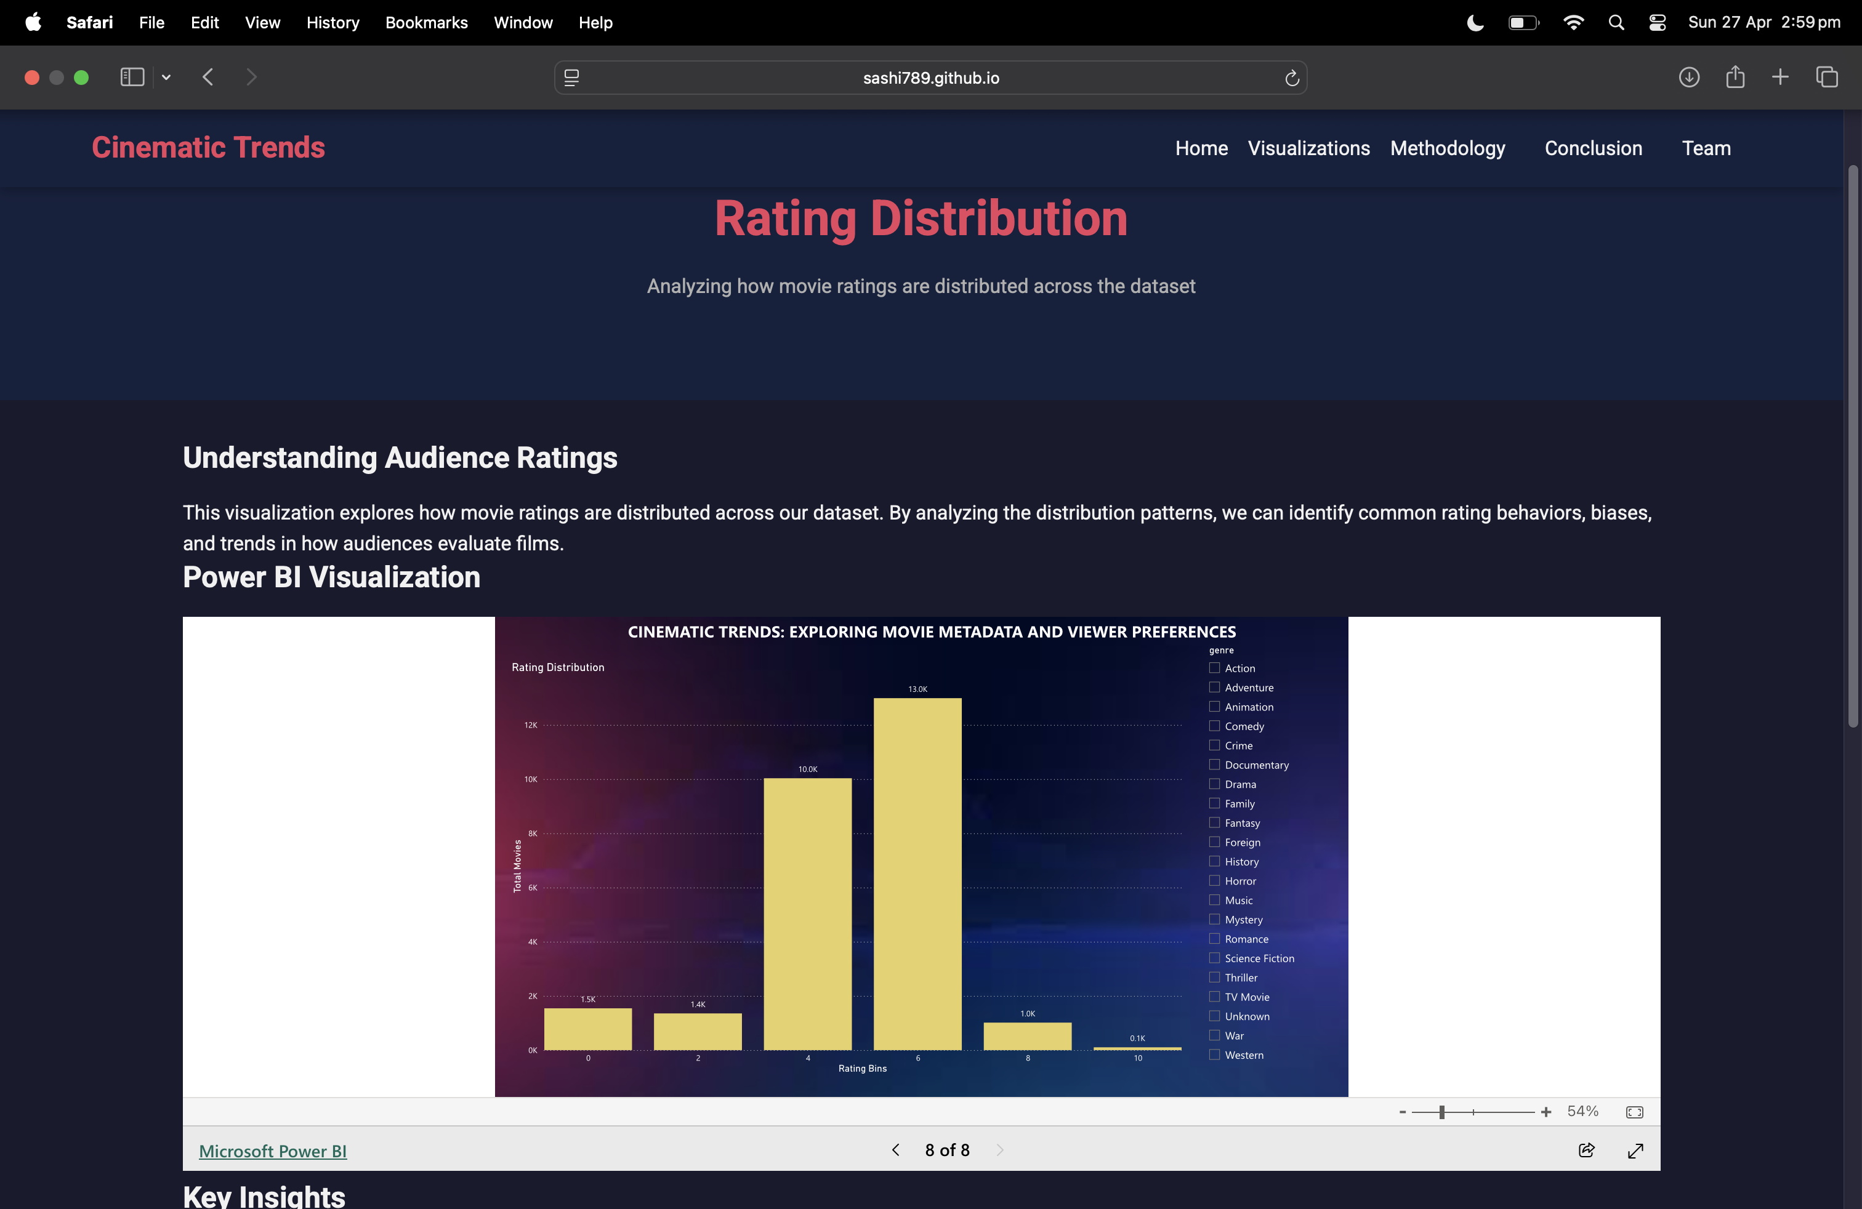

Dashboard View: Movie Data Analysis

* This visualization presents an interactive **D3.js-based** view of movie rating distributions, focusing on the spread and density of viewer ratings.
* It provides a more granular, visually engaging exploration of how ratings are distributed across thousands of films, offering a deeper layer of user engagement compared to traditional charts.

This integration of custom visualization tools enhances the analytical capabilities of the Cinematic Trends platform

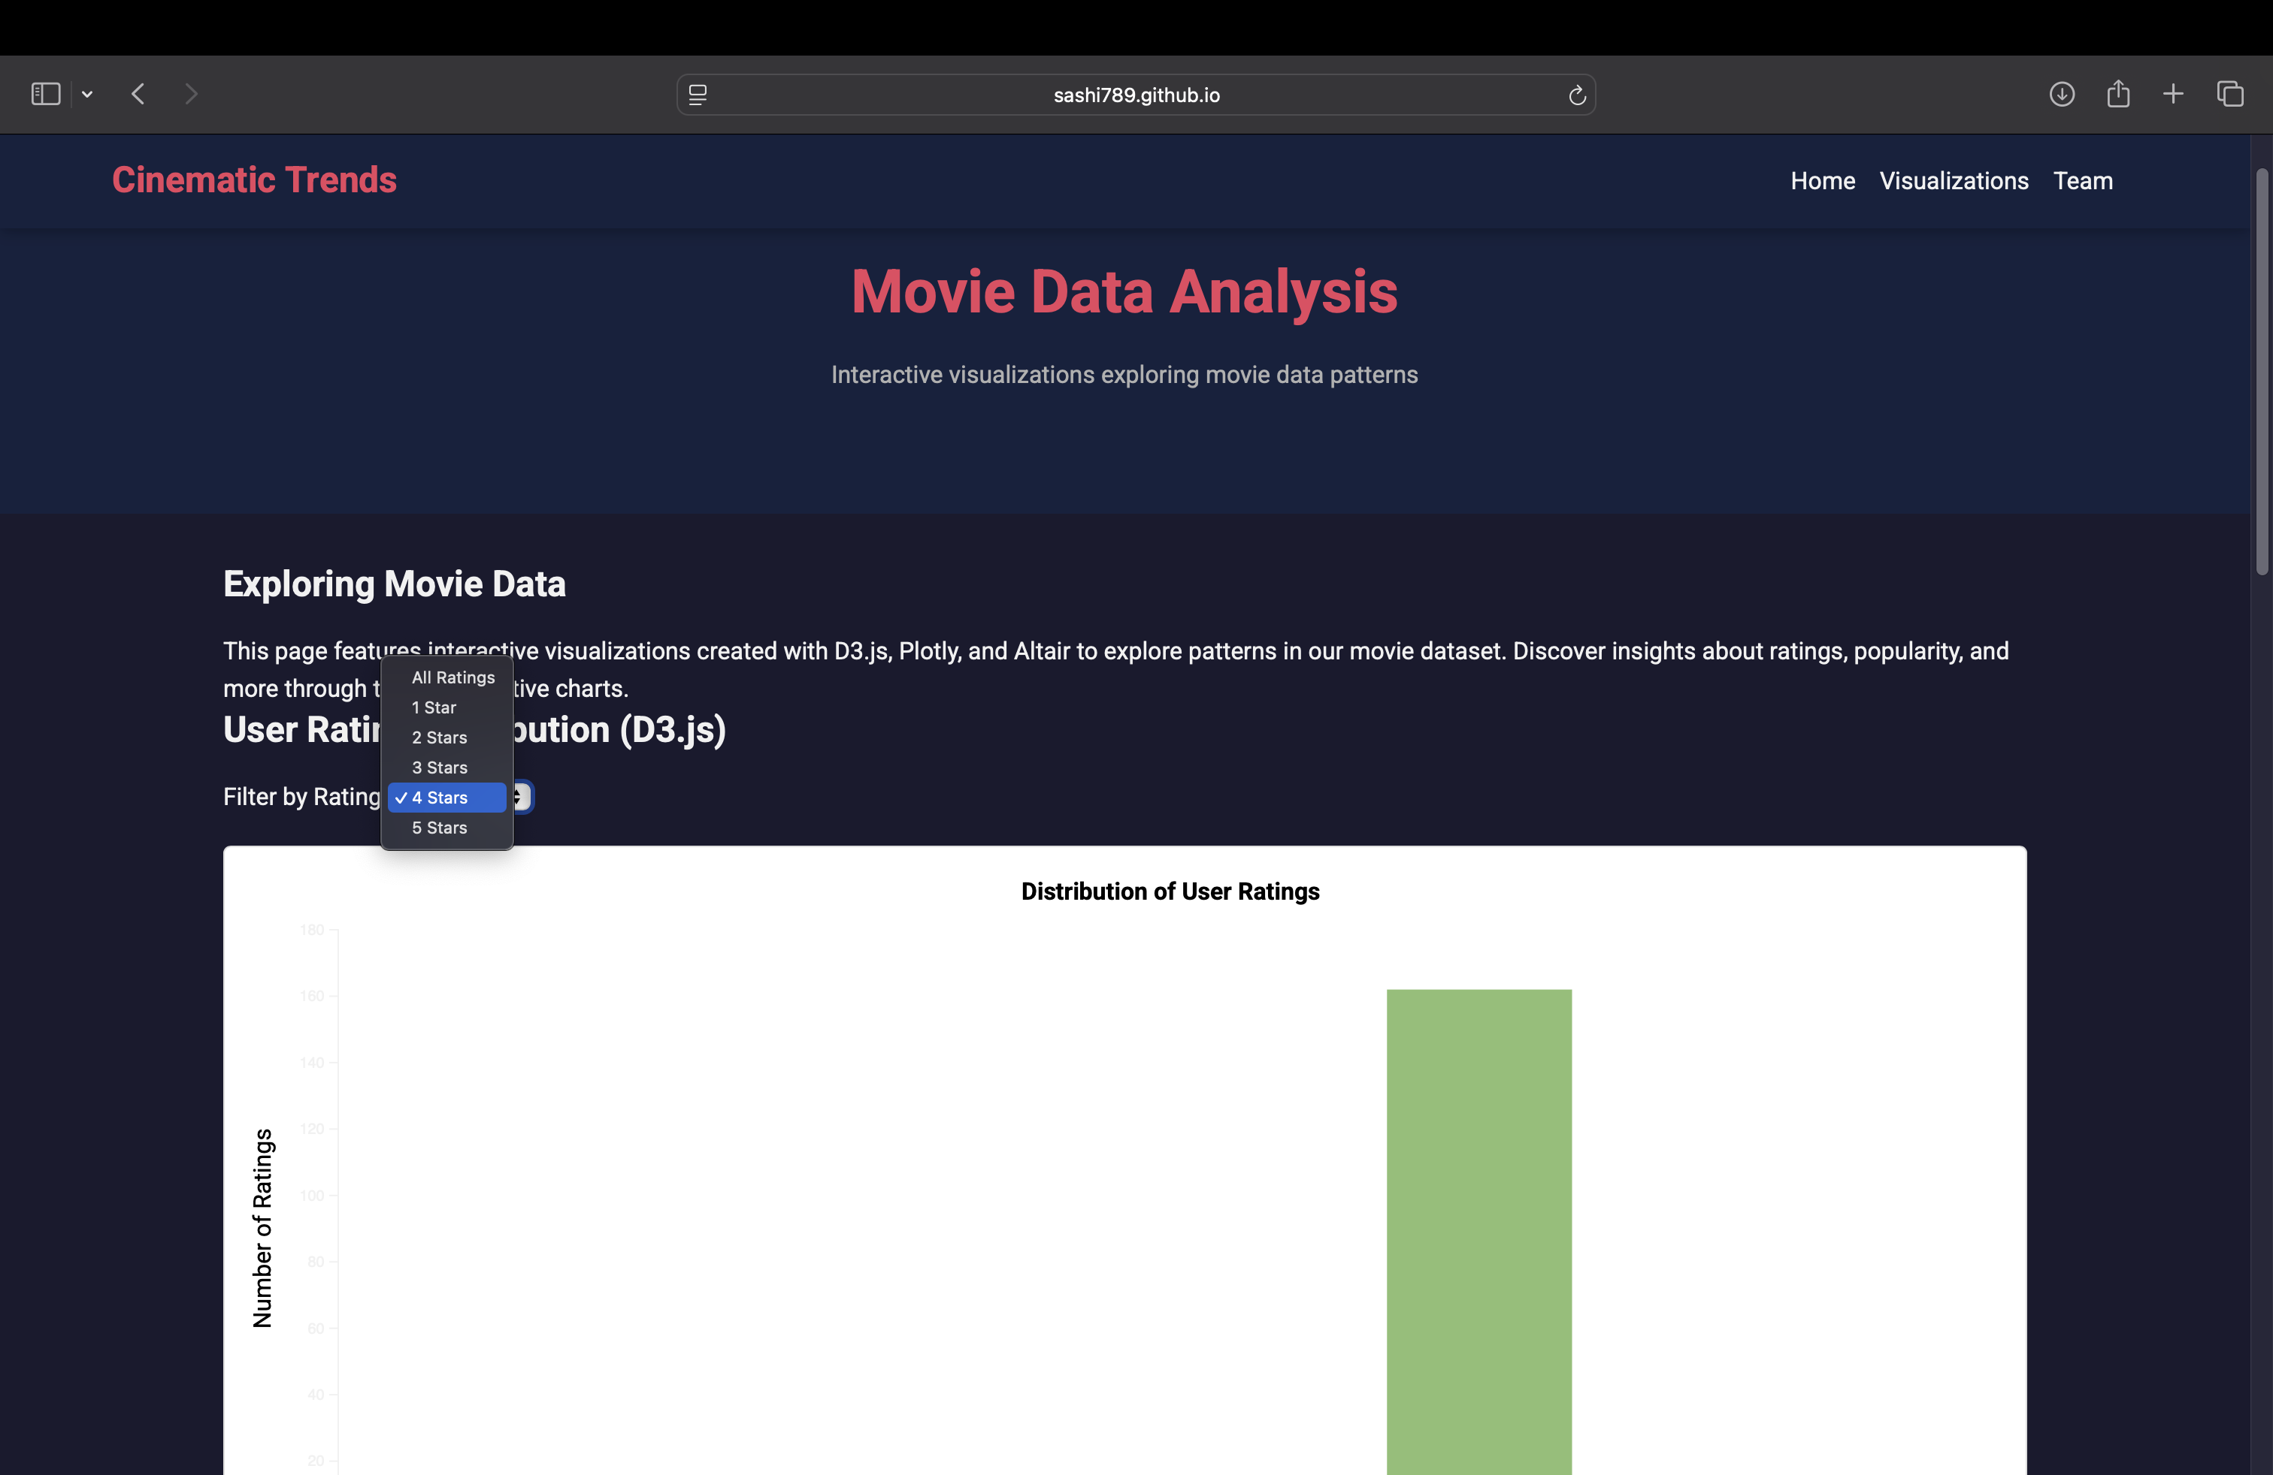

Methodology:

**Data Collection**

* Gathered two primary datasets from Kaggle’s TMDB Collection: movies_metadata.csv and ratings.csv.
* Selected datasets for comprehensiveness, reliability, and relevance to cinematic trends and viewer behavior.
* Focused on movie details (budget, revenue, genres) and user ratings to build a robust foundation for analysis.

**Data Preprocessing**

* Removed duplicates, handled missing values, corrected inconsistencies for clean data.
* Transformed complex fields (e.g., JSON genre parsing) and normalized monetary values.
* Merged metadata and ratings datasets into a final enriched dataset (movies_data.csv).

**Analysis Approach**

* Performed **Exploratory Data Analysis (EDA)** to understand distributions and initial patterns.
* Conducted **Temporal and Comparative Analyses** across genres, languages, and time periods.
* Identified significant patterns and correlations while ensuring statistical validity and minimizing bias.

**Visualization Techniques**

* Created scatter plots, bar charts, line charts, heatmaps, and choropleth maps for insights.
* Built interactive dashboards and custom visualizations using Power BI, D3.js, and Plotly.js.
* Focused on clarity, simplicity, and user-driven exploration with responsive design principles.

**Validation and Quality Assurance**

* Cross-validated results using multiple analytical methods to ensure reliability.
* Conducted sensitivity analysis to understand impacts of assumptions and data limitations.
* Performed peer review and user testing to refine visualizations and improve usability.

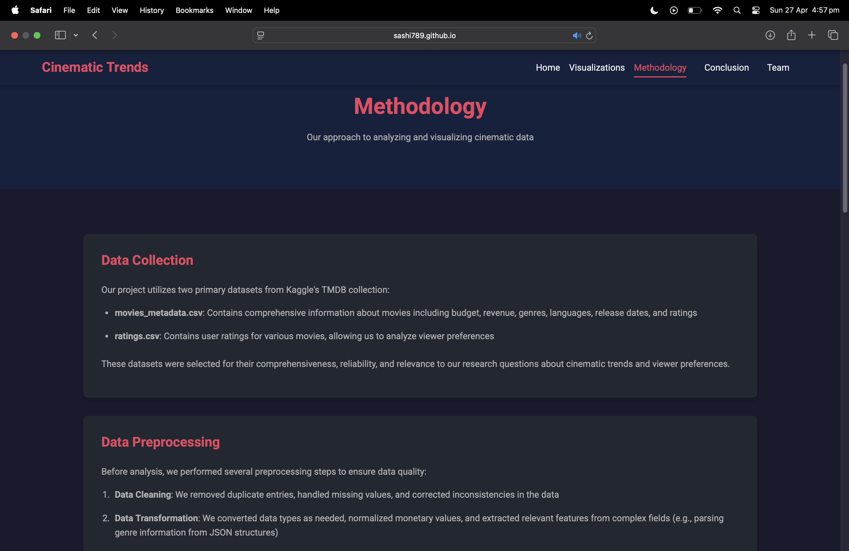

Conclusion:

Our project, *Cinematic Trends*, successfully explored key insights into the movie industry by combining metadata and user ratings from large datasets.

**Key Findings:**

* **Budget vs Revenue Relationship:**  
  Higher budgets often correlate with higher revenues, but mid-budget films frequently show better ROI. Genre type significantly impacts financial success.
* **Genre Preferences:**  
  Genres such as Animation, Documentary, and Adventure consistently receive higher viewer ratings, while Horror and Thriller genres show more polarized audience reactions.
* **Language and Global Appeal:**  
  While English-language films dominate, several non-English productions, particularly in Korean, Spanish, and French, have achieved significant international success.
* **Temporal Trends:**  
  Movie popularity and viewer preferences have evolved over time, with the rise of sci-fi and superhero genres and an overall increase in average ratings post-2000.

**Project Outcome:**

* Developed an interactive web platform for dynamic exploration of cinematic data trends.
* Provided users with the ability to filter, explore, and interpret movie insights in an engaging, accessible way.
* Successfully transitioned from static dashboards to a fully deployed web-based interactive system.

**Work Management:**

As mentioned in the proposal below, tasks have been completed for the project 1:

* Explored metadata features like genres, average ratings, popularity
* Detected basic correlations such as genre vs. average rating, release year vs. popularity
* Identified outliers and missing data
* Generated initial visual dashboards

**Data Cleaning & Transformation:**

* Handle missing or inconsistent values in the movies_metadata.csv file (e.g., missing runtimes, differently formatted release dates).
* Convert data types (e.g., release dates to datetime, budget/revenue to numeric).

**Exploratory Data Analysis (EDA):**

* Analyze the distribution of movie genres, release years, and popularity scores.
* Visualize the average user rating across different genres and decades.
* Create basic visualizations using Power BI

**Initial Correlation Analysis:**

* Identify relationships between variables such as:
* Movie runtime vs. average rating
* Budget/revenue vs. popularity
* Number of ratings vs. movie rating score

|  |  |  |
| --- | --- | --- |
| Name of the person | Responsibility taken | Percentage distribution |
| Sashidhar Chary Viswanathula | Worked on data cleaning, transformation, two visualizations and documentation | 40% |
| Nithish Karanam | Worked on four visualizations and documentation | 30% |
| Vidya Reddy | Worked on two visualizations and documentation | 30% |